## Winter Internship on Cyber Security and Vulnerability Assessment

## At

## Assam Electronics Development Corporation, Assam

Submitted by

Tuhin Barman

Niraj Uppadhya

Ammiel Peters

Under Guidance

Kangkan Mahanta

System and Solution Architect

Assam Electronics Development Corporation

Bamunimaidan, Guwahati, Assam

## A Definition of Cyber Security

Cyber security refers to the body of technologies, processes, and practices designed to protect networks, devices, programs, and data from attack, damage, or unauthorized access. Cyber security may also be referred to as information technology security.

## The Importance of Cyber Security

Cyber security is important because government, military, corporate, financial, and medical organizations collect, process, and store unprecedented amounts of data on computers and other devices. A significant portion of that data can be sensitive information, whether that be intellectual property, financial data, personal information, or other types of data for which unauthorized access or exposure could have negative consequences. Organizations transmit sensitive data across networks and to other devices in the course of doing businesses, and cyber security describes the discipline dedicated to protecting that information and the systems used to process or store it. As the volume and sophistication of cyber attacks grow, companies and organizations, especially those that are tasked with safeguarding information relating to national security, health, or financial records, need to take steps to protect their sensitive business and personnel information. As early as March 2013, the nation’s top intelligence officials cautioned that cyber attacks and digital spying are the top threat to national security, eclipsing even terrorism.

## Challenges of Cyber Security

For an effective cyber security, an organization needs to coordinate its efforts throughout its entire information system. Elements of cyber encompass all of the following:

* Network security
* Application security
* Endpoint security
* Data security
* Identity management
* Database and infrastructure security
* Cloud security
* Mobile security
* Disaster recovery/business continuity planning
* End-user education

The most difficult challenge in cyber security is the ever-evolving nature of security risks themselves. Traditionally, organizations and the government have focused most of their cyber security resources on perimeter security to protect only their most crucial system components and defend against known treats. Today, this approach is insufficient, as the threats advance and change more quickly than organizations can keep up with. As a result, advisory organizations promote more proactive and adaptive approaches to cyber security. Similarly, the National Institute of Standards and Technology (NIST) issued guidelines in its risk assessment framework that recommend a shift toward continuous monitoring and real-time assessments, a data-focused approach to security as opposed to the traditional perimeter-based model.

## Vulnerabilities and attacks

A vulnerability is a weakness in design, implementation, operation or internal control. Most of the vulnerabilities that have been discovered are documented in the Common Vulnerabilities and Exposures (CVE) database. An *exploitable* vulnerability is one for which at least one working attack or "exploit" exists. Vulnerabilities are often hunted or exploited with the aid of automated tools or manually using customized scripts. To secure a computer system, it is important to understand the attacks that can be made against it, and these threats can typically be classified into one of these categories below:

### Denial-of-service attack

Denial of service attacks (DoS) are designed to make a machine or network resource unavailable to its intended users. Attackers can deny service to individual victims, such as by deliberately entering a wrong password enough consecutive times to cause the victims account to be locked, or they may overload the capabilities of a machine or network and block all users at once. While a network attack from a single IP address can be blocked by adding a new firewall rule, many forms of Distributed denial of service (DDoS) attacks are possible, where the attack comes from a large number of points – and defending is much more difficult. Such attacks can originate from the zombie computers of a botnet, but a range of other techniques are possible including reflection and amplification attacks, where innocent systems are fooled into sending traffic to the victim.

### Backdoor

A backdoor in a computer system, a cryptosystem or an algorithm, is any secret method of bypassing normal authentication or security controls. They may exist for a number of reasons, including by original design or from poor configuration. They may have been added by an authorized party to allow some legitimate access, or by an attacker for malicious reasons; but regardless of the motives for their existence, they create a vulnerability.

### Direct-access attacks

An unauthorized user gaining physical access to a computer is most likely able to directly copy data from it. They may also compromise security by making operating system modifications, installing software worms, keyloggers, covert listening devices or using wireless mice. Even when the system is protected by standard security measures, these may be able to be by-passed by booting another operating system or tool from a CD-ROM or other bootable media. Disk encryption and Trusted Platform Module are designed to prevent these attacks.

### Eavesdropping

Eavesdropping is the act of surreptitiously listening to a private computer "conversation" (communication), typically between hosts on a network. For instance, programs such as Carnivore and NarusInSight have been used by the FBI and NSA to eavesdrop on the systems of internet service providers. Even machines that operate as a closed system (i.e., with no contact to the outside world) can be eavesdropped upon via monitoring the faint electromagnetic transmissions generated by the hardware; TEMPEST is a specification by the NSA referring to these attacks.

### Phishing

Phishing is the attempt to acquire sensitive information such as usernames, passwords, and credit card details directly from users by deceiving the users.[8] Phishing is typically carried out by email spoofing or instant messaging, and it often directs users to enter details at a fake website whose "look" and "feel" are almost identical to the legitimate one. The fake website often asks for personal information, such as log-in details and passwords. This information can then be used to gain access to the individual's real account on the real website. Preying on a victim's trust, phishing can be classified as a form of social engineering.

### Social engineering

Social engineering aims to convince a user to disclose secrets such as passwords, card numbers, etc. by, for example, impersonating a bank, a contractor, or a customer.

A common scam involves fake CEO emails sent to accounting and finance departments. In early 2016, the FBI reported that the scam has cost US businesses more than $2bn in about two years.

In May 2016, the Milwaukee Bucks NBA team was the victim of this type of cyber scam with a perpetrator impersonating the team's president Peter Feigin, resulting in the handover of all the team's employees' 2015 W-2 tax forms.

### Spoofing

Spoofing is the act of masquerading as a valid entity through falsification of data (such as an IP address or username), in order to gain access to information or resources that one is otherwise unauthorized to obtain. There are several types of spoofing, including:

* Email spoofing, where an attacker forges the sending (*From*, or source) address of an email.
* IP address spoofing, where an attacker alters the source IP address in a network packet to hide their identity or impersonate another computing system.
* MAC spoofing, where an attacker modifies the Media Access Control (MAC) address of their network interface to pose as a valid user on a network.
* Biometric spoofing, where an attacker produces a fake biometric sample to pose as another user.

## Impact of security breaches

Serious financial damage has been caused by security breaches, but because there is no standard model for estimating the cost of an incident, the only data available is that which is made public by the organizations involved. "Several computer security consulting firms produce estimates of total worldwide losses attributable to virus and worm attacks and to hostile digital acts in general. The 2003 loss estimates by these firms range from $13 billion (worms and viruses only) to $226 billion (for all forms of covert attacks). The reliability of these estimates is often challenged; the underlying methodology is basically anecdotal." Security breaches continue to cost businesses billions of dollars but a survey revealed that 66% of security staffs do not believe senior leadership takes cyber precautions as a strategic priority.

However, reasonable estimates of the financial cost of security breaches can actually help organizations make rational investment decisions. According to the classic Gordon-Loeb Model analyzing the optimal investment level in information security, one can conclude that the amount a firm spends to protect information should generally be only a small fraction of the expected loss (i.e., the expected value of the loss resulting from a cyber/information security breach).

## Cyber Security protection (countermeasures)

In computer security a countermeasure is an action, device, procedure, or technique that reduces a threat, a vulnerability, or an attack by eliminating or preventing it, by minimizing the harm it can cause, or by discovering and reporting it so that corrective action can be taken.

Some common countermeasures are listed in the following sections:

### Security by design

Security by design, or alternately secure by design, means that the software has been designed from the ground up to be secure. In this case, security is considered as a main feature.

Some of the techniques in this approach include:

* The principle of least privilege, where each part of the system has only the privileges that are needed for its function. That way even if an attacker gains access to that part, they have only limited access to the whole system.
* Automated theorem proving to prove the correctness of crucial software subsystems.
* Code reviews and unit testing, approaches to make modules more secure where formal correctness proofs are not possible.
* Defense in depth, where the design is such that more than one subsystem needs to be violated to compromise the integrity of the system and the information it holds.
* Default secure settings, and design to "fail secure" rather than "fail insecure" (see fail-safe for the equivalent in safety engineering). Ideally, a secure system should require a deliberate, conscious, knowledgeable and free decision on the part of legitimate authorities in order to make it insecure.
* Audit trails tracking system activity, so that when a security breach occurs, the mechanism and extent of the breach can be determined. Storing audit trails remotely, where they can only be appended to, can keep intruders from covering their tracks.
* Full disclosure of all vulnerabilities, to ensure that the "window of vulnerability" is kept as short as possible when bugs are discovered.

### Vulnerability management

Vulnerability management is the cycle of identifying, and remediating or mitigating vulnerabilities, especially in software and firmware. Vulnerability management is integral to computer security and network security.

Vulnerabilities can be discovered with a vulnerability scanner, which analyzes a computer system in search of known vulnerabilities, such as open ports, insecure software configuration, and susceptibility to malware.

Beyond vulnerability scanning, many organizations contract outside security auditors to run regular penetration tests against their systems to identify vulnerabilities. In some sectors, this is a contractual requirement.

### Security architecture

The Open Security Architecture organization defines IT security architecture as "the design artifacts that describe how the security controls (security countermeasures) are positioned, and how they relate to the overall information technology architecture. These controls serve the purpose to maintain the system's quality attributes: confidentiality, integrity, availability, accountability and assurance services".

Techopedia defines security architecture as "a unified security design that addresses the necessities and potential risks involved in a certain scenario or environment. It also specifies when and where to apply security controls. The design process is generally reproducible." The key attributes of security architecture are:

* the relationship of different components and how they depend on each other.
* the determination of controls based on risk assessment, good practice, finances, and legal matters.
* the standardization of controls.

### Security measures

A state of computer "security" is the conceptual ideal, attained by the use of the three processes: threat prevention, detection, and response. These processes are based on various policies and system components, which include the following:

* User account access controls and cryptography can protect systems files and data, respectively.
* Firewalls are by far the most common prevention systems from a network security perspective as they can (if properly configured) shield access to internal network services, and block certain kinds of attacks through packet filtering. Firewalls can be both hardware- or software-based.
* Intrusion Detection System (IDS) products are designed to detect network attacks in-progress and assist in post-attack forensics, while audit trails and logs serve a similar function for individual systems.
* "Response" is necessarily defined by the assessed security requirements of an individual system and may cover the range from simple upgrade of protections to notification of legal authorities, counter-attacks, and the like. In some special cases, a complete destruction of the compromised system is favored, as it may happen that not all the compromised resources are detected.

Today, computer security comprises mainly "preventive" measures, like firewalls or an exit procedure. A firewall can be defined as a way of filtering network data between a host or a network and another network, such as the Internet, and can be implemented as software running on the machine, hooking into the network stack (or, in the case of most UNIX-based operating systems such as Linux, built into the operating system kernel) to provide real-time filtering and blocking. Another implementation is a so-called "physical firewall", which consists of a separate machine filtering network traffic. Firewalls are common amongst machines that are permanently connected to the Internet.

Some organizations are turning to big data platforms, such as Apache Hadoop, to extend data accessibility and machine learning to detect advanced persistent threats.

However, relatively few organisations maintain computer systems with effective detection systems, and fewer still have organized response mechanisms in place. As a result, as Reuters points out: "Companies for the first time report they are losing more through electronic theft of data than physical stealing of assets". The primary obstacle to effective eradication of cyber crime could be traced to excessive reliance on firewalls and other automated "detection" systems. Yet it is basic evidence gathering by using packet capture appliances that puts criminals behind bars.

### Reducing vulnerabilities

While formal verification of the correctness of computer systems is possible, it is not yet common. Operating systems formally verified include seL4, and SYSGO's PikeOS – but these make up a very small percentage of the market.

Two factor authentication is a method for mitigating unauthorized access to a system or sensitive information. It requires "something you know"; a password or PIN, and "something you have"; a card, dongle, cellphone, or other piece of hardware. This increases security as an unauthorized person needs both of these to gain access.

Social engineering and direct computer access (physical) attacks can only be prevented by non-computer means, which can be difficult to enforce, relative to the sensitivity of the information. Training is often involved to help mitigate this risk, but even in a highly disciplined environments (e.g. military organizations), social engineering attacks can still be difficult to foresee and prevent.

Enoculation, derived from inoculation theory, seeks to prevent social engineering and other fraudulent tricks or traps by instilling a resistance to persuasion attempts through exposure to similar or related attempts.

It is possible to reduce an attacker's chances by keeping systems up to date with security patches and updates, using a security scanner or/and hiring competent people responsible for security.(This statement is ambiguous. Even systems developed by "competent" people get penetrated) The effects of data loss/damage can be reduced by careful backing up and insurance.

### Hardware protection mechanisms

While hardware may be a source of insecurity, such as with microchip vulnerabilities maliciously introduced during the manufacturing process, hardware-based or assisted computer security also offers an alternative to software-only computer security. Using devices and methods such as dongles, trusted platform modules, intrusion-aware cases, drive locks, disabling USB ports, and mobile-enabled access may be considered more secure due to the physical access (or sophisticated backdoor access) required in order to be compromised. Each of these is covered in more detail below.

* USB dongles are typically used in software licensing schemes to unlock software capabilities, but they can also be seen as a way to prevent unauthorized access to a computer or other device's software. The dongle, or key, essentially creates a secure encrypted tunnel between the software application and the key. The principle is that an encryption scheme on the dongle, such as Advanced Encryption Standard (AES) provides a stronger measure of security, since it is harder to hack and replicate the dongle than to simply copy the native software to another machine and use it. Another security application for dongles is to use them for accessing web-based content such as cloud software or Virtual Private Networks (VPNs). In addition, a USB dongle can be configured to lock or unlock a computer.
* Trusted platform modules (TPMs) secure devices by integrating cryptographic capabilities onto access devices, through the use of microprocessors, or so-called computers-on-a-chip. TPMs used in conjunction with server-side software offer a way to detect and authenticate hardware devices, preventing unauthorized network and data access.
* Computer case intrusion detection refers to a device, typically a push-button switch, which detects when a computer case is opened. The firmware or BIOS is programmed to show an alert to the operator when the computer is booted up the next time.
* Drive locks are essentially software tools to encrypt hard drives, making them inaccessible to thieves. Tools exist specifically for encrypting external drives as well.
* Disabling USB ports is a security option for preventing unauthorized and malicious access to an otherwise secure computer. Infected USB dongles connected to a network from a computer inside the firewall are considered by the magazine Network World as the most common hardware threat facing computer networks.
* Disconnecting or disabling peripheral devices ( like camera, GPS, removable storage etc.), that are not in use.
* Mobile-enabled access devices are growing in popularity due to the ubiquitous nature of cell phones. Built-in capabilities such as Bluetooth, the newer Bluetooth low energy (LE), Near field communication (NFC) on non-iOS devices and biometric validation such as thumb print readers, as well as QR code reader software designed for mobile devices, offer new, secure ways for mobile phones to connect to access control systems. These control systems provide computer security and can also be used for controlling access to secure buildings.

### Secure operating systems

One use of the term "computer security" refers to technology that is used to implement secure operating systems. In the 1980s the United States Department of Defense (DoD) used the "Orange Book" standards, but the current international standard ISO/IEC 15408, "Common Criteria" defines a number of progressively more stringent Evaluation Assurance Levels. Many common operating systems meet the EAL4 standard of being "Methodically Designed, Tested and Reviewed", but the formal verification required for the highest levels means that they are uncommon. An example of an EAL6 ("Semiformally Verified Design and Tested") system is Integrity-178B, which is used in the Airbus A380 and several military jets.

### Secure coding

In software engineering, secure coding aims to guard against the accidental introduction of security vulnerabilities. It is also possible to create software designed from the ground up to be secure. Such systems are "secure by design". Beyond this, formal verification aims to prove the correctness of the algorithms underlying a system; important for cryptographic protocols for example.

### Capabilities and access control lists

Within computer systems, two of many security models capable of enforcing privilege separation are access control lists (ACLs) and capability-based security. Using ACLs to confine programs has been proven to be insecure in many situations, such as if the host computer can be tricked into indirectly allowing restricted file access, an issue known as the confused deputy problem. It has also been shown that the promise of ACLs of giving access to an object to only one person can never be guaranteed in practice. Both of these problems are resolved by capabilities. This does not mean practical flaws exist in all ACL-based systems, but only that the designers of certain utilities must take responsibility to ensure that they do not introduce flaws.

Capabilities have been mostly restricted to research operating systems, while commercial OSs still use ACLs. Capabilities can, however, also be implemented at the language level, leading to a style of programming that is essentially a refinement of standard object-oriented design. An open source project in the area is the E language.

### Digital hygiene

Related to end-user training, **digital hygiene** or **cyber hygiene** is a fundamental principle relating to information security and, as the analogy with personal hygiene shows, is the equivalent of establishing simple routine measures to minimise the risks from cyber threats. The assumption is that good cyber hygiene practices can give networked users another layer of protection, reducing the risk that one vulnerable node will be used to either mount attacks or compromise another node or network, especially from common cyberattacks.

As opposed to a purely technology-based defense against threats, cyber hygiene mostly regards routine measures that are technically simple to implement and mostly dependent on disciplineor education. It can be thought of as an abstract list of tips or measures that have been demonstrated as having a positive effect on personal and/or collective digital security. As such, these measures can be performed by laypeople, not just security experts.

Cyber hygiene relates to personal hygiene as computer viruses relate to biological viruses (or pathogens). However, while the term *computer virus* was coined almost simultaneously with the creation of the first working computer viruses, the term *cyber hygiene* is a much later invention, perhaps as late as 2000 by Internet pioneer Vint Cerf. It has since been adopted by the Congress and Senate of the United States, the FBI, EU institutions and heads of state.

Cyber hygiene should also not be mistaken for proactive cyber defence, a military term.

### Response to breaches

Responding forcefully to attempted security breaches (in the manner that one would for attempted physical security breaches) is often very difficult for a variety of reasons:

* Identifying attackers is difficult, as they are often in a different jurisdiction to the systems they attempt to breach, and operate through proxies, temporary anonymous dial-up accounts, wireless connections, and other anonymizing procedures which make back tracing difficult and are often located in yet another jurisdiction. If they successfully breach security, they are often able to delete logs to cover their tracks.
* The sheer number of attempted attacks is so large that organisations cannot spend time pursuing each attacker (a typical home user with a permanent (e.g., cable modem) connection will be attacked at least several times per day, so more attractive targets could be presumed to see many more). Note however, that most of the sheer bulk of these attacks are made by automated vulnerability scanners and computer worms.
* Law enforcement officers are often unfamiliar with information technology, and so lack the skills and interest in pursuing attackers. There are also budgetary constraints. It has been argued that the high cost of technology, such as DNA testing, and improved forensics mean less money for other kinds of law enforcement, so the overall rate of criminals not getting dealt with goes up as the cost of the technology increases. In addition, the identification of attackers across a network may require logs from various points in the network and in many countries, the release of these records to law enforcement (with the exception of being voluntarily surrendered by a network administrator or a system administrator) requires a search warrant and, depending on the circumstances, the legal proceedings required can be drawn out to the point where the records are either regularly destroyed, or the information is no longer relevant.

### Types of security and privacy

* Anti-keyloggers
* Anti-malware
* Anti-spyware
* Anti-subversion software
* Anti-tamper software
* Anti-theft
* Antivirus software
* Cryptographic software
* Computer-aided dispatch (CAD)
* Intrusion detection system (IDS)
* Intrusion prevention system (IPS)
* Log management software
* Parental control
* Records management
* Sandbox
* Security information management
* SIEM
* Firewall
* Access Control
* Software and operating system updating

**Hands on demonstration on vulnerability testing and report generation**

**Objective :** The objective of performing a Vulnerability Assessment is to create an overview of the security risks to a network and then use that overview as a guideline to resolve those threats. Performing regular assessments and routinely resolving all security risks provides a baseline security for the network. Administrators and users can feel confident that potential attackers will be unable to exploit vulnerabilities on their network.

**Software Used :**

1. Windows 11
2. CentOS 7
3. Virtual Box
4. Nessus

**Steps to achieve the lab objectives**

1. Download and install Virtual Box in Host Operating System “Windows 11”
2. Deploy 2 virtual machine with 2VCPU, 4GB RAM and 20GB HDD
3. Configure virtual machine network manually to assign static IP
4. Download, install and host wordpress in the running virtual machine
5. Deploy demo website
6. Install Nessus in host operating system “Windows 11”
7. Configure nessus and deploy vulnerability assessment plan on deployed virtual machine
8. Generate report

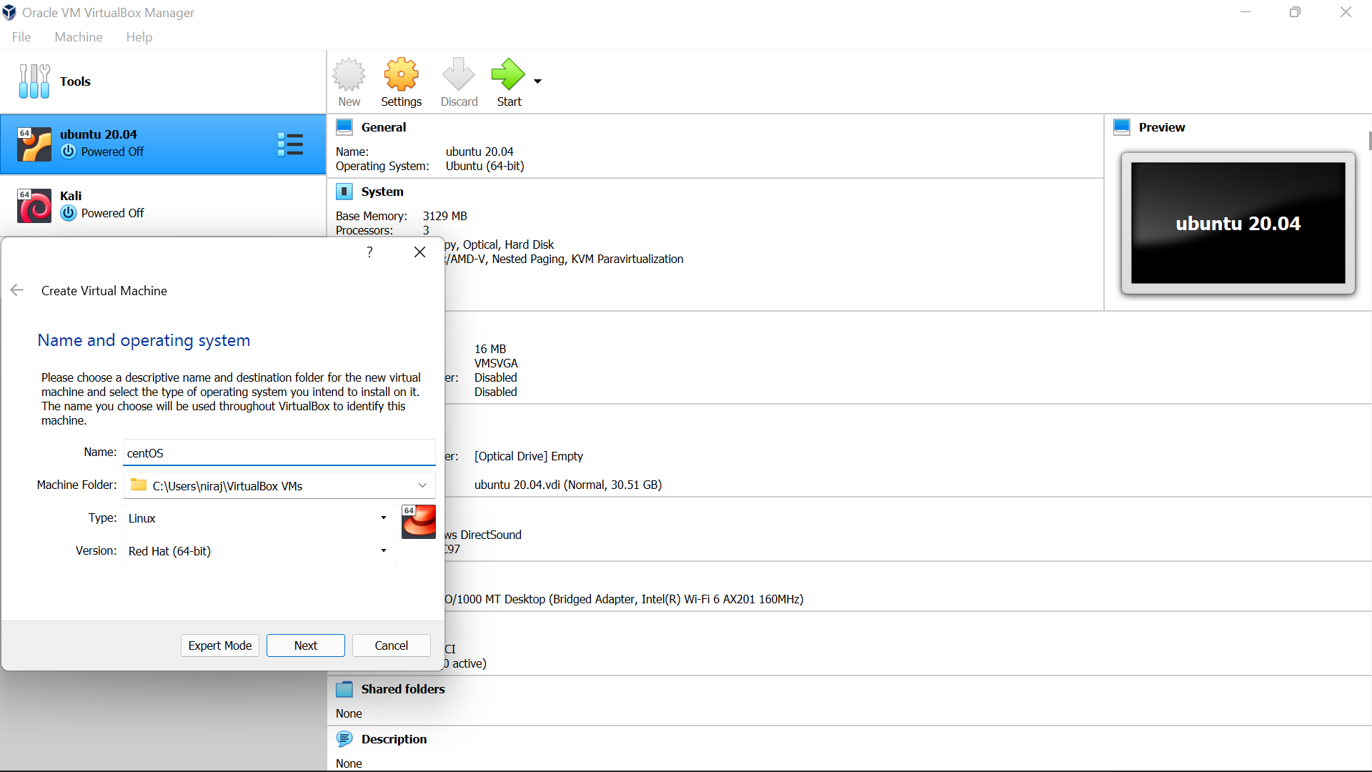 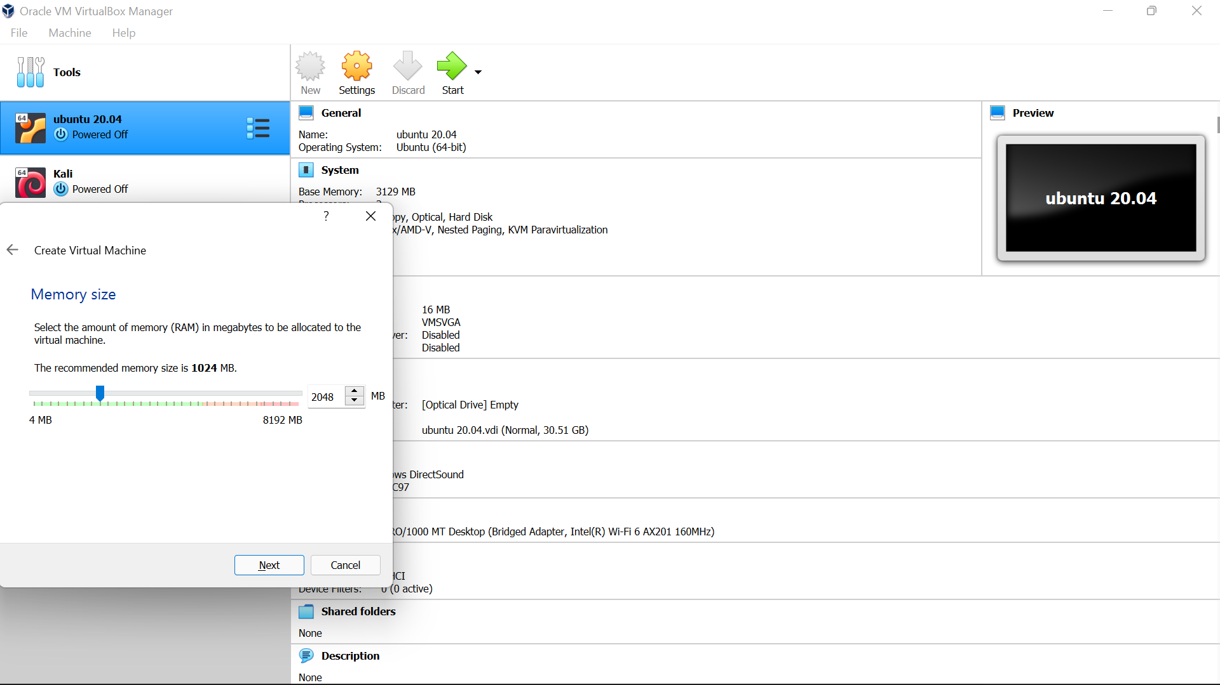 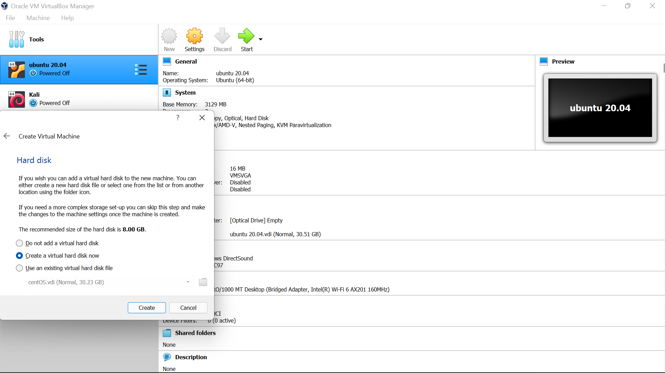 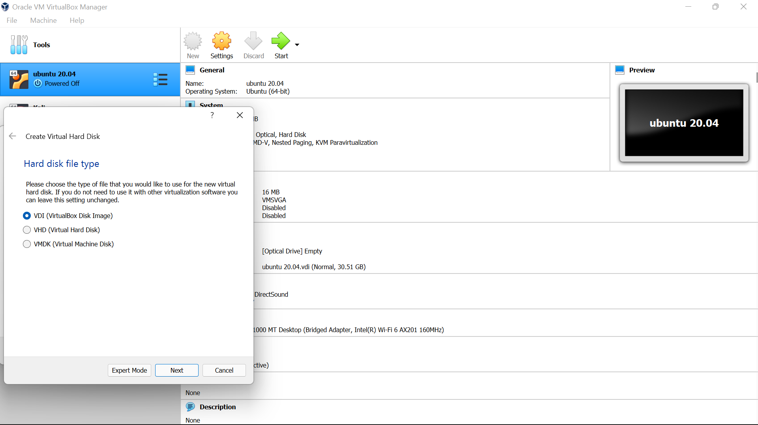 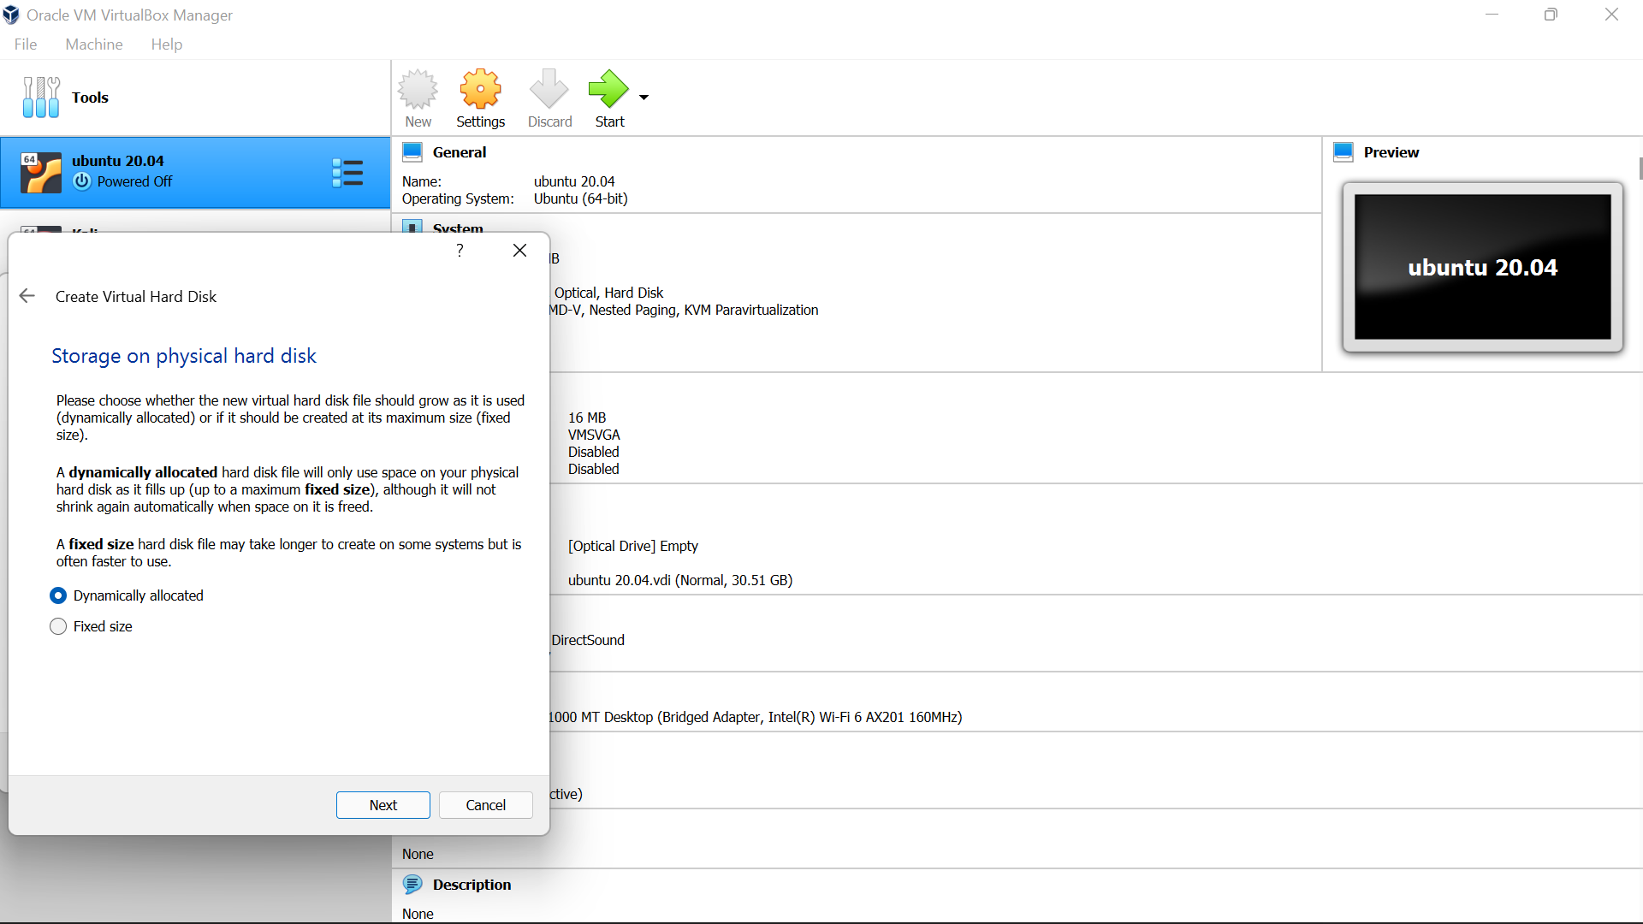 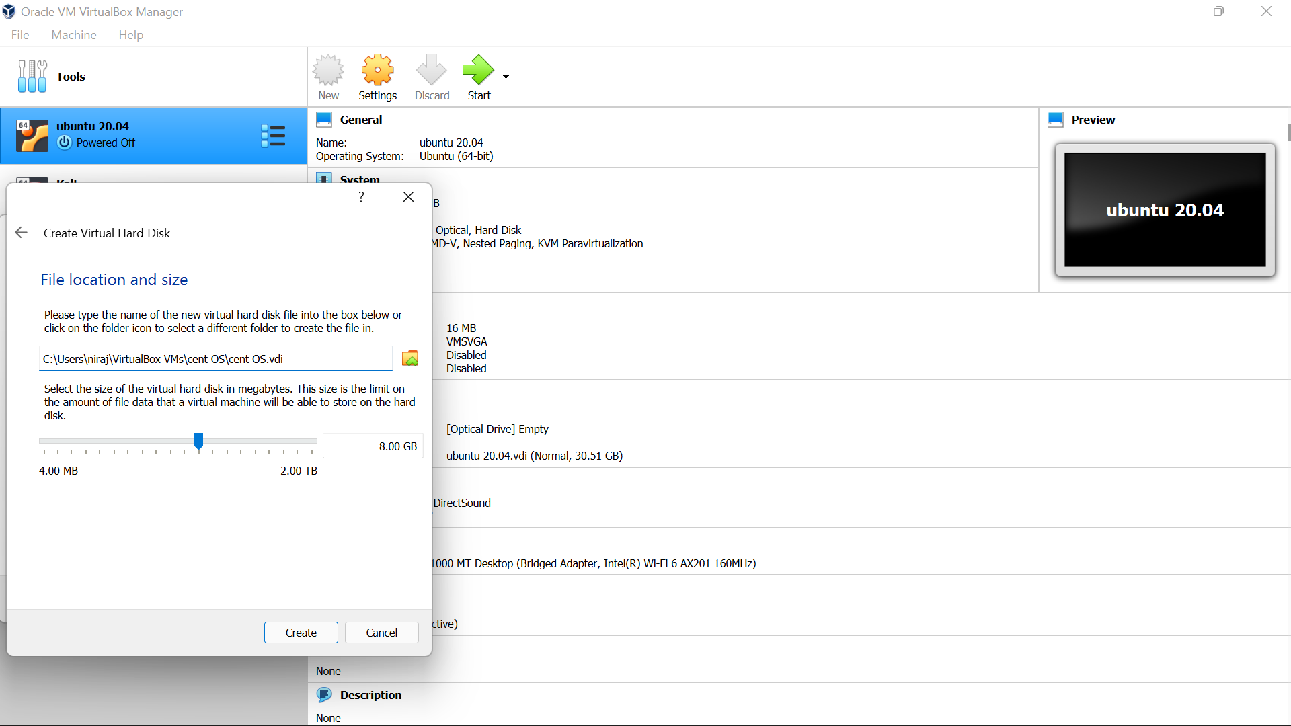 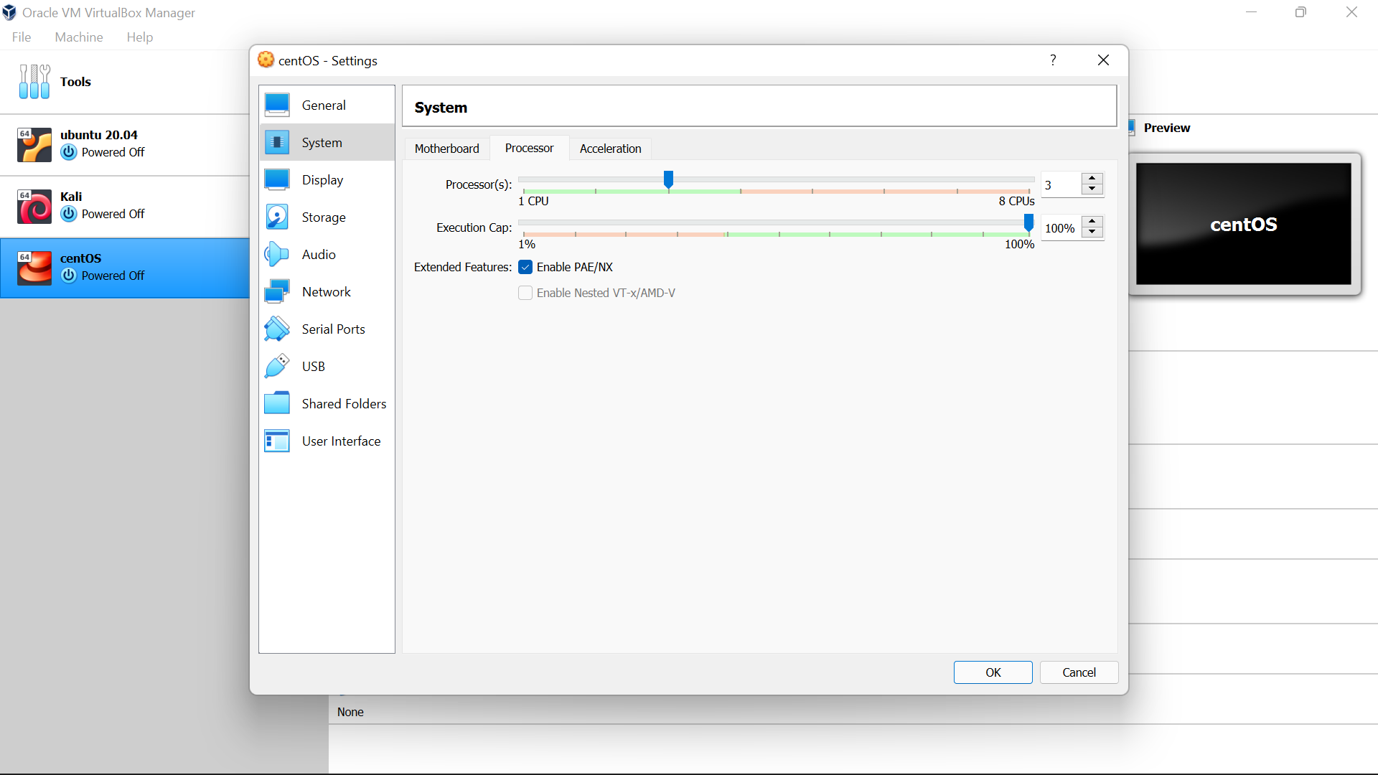 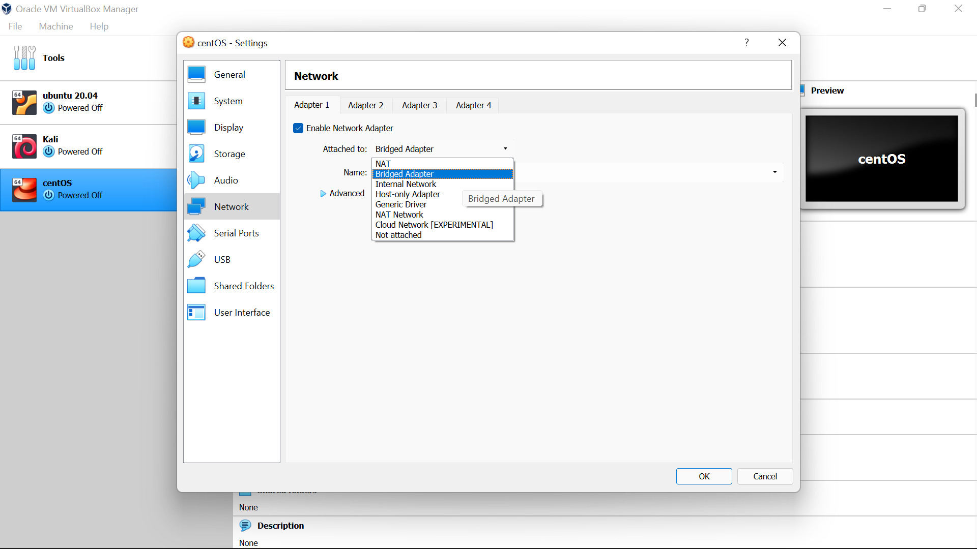 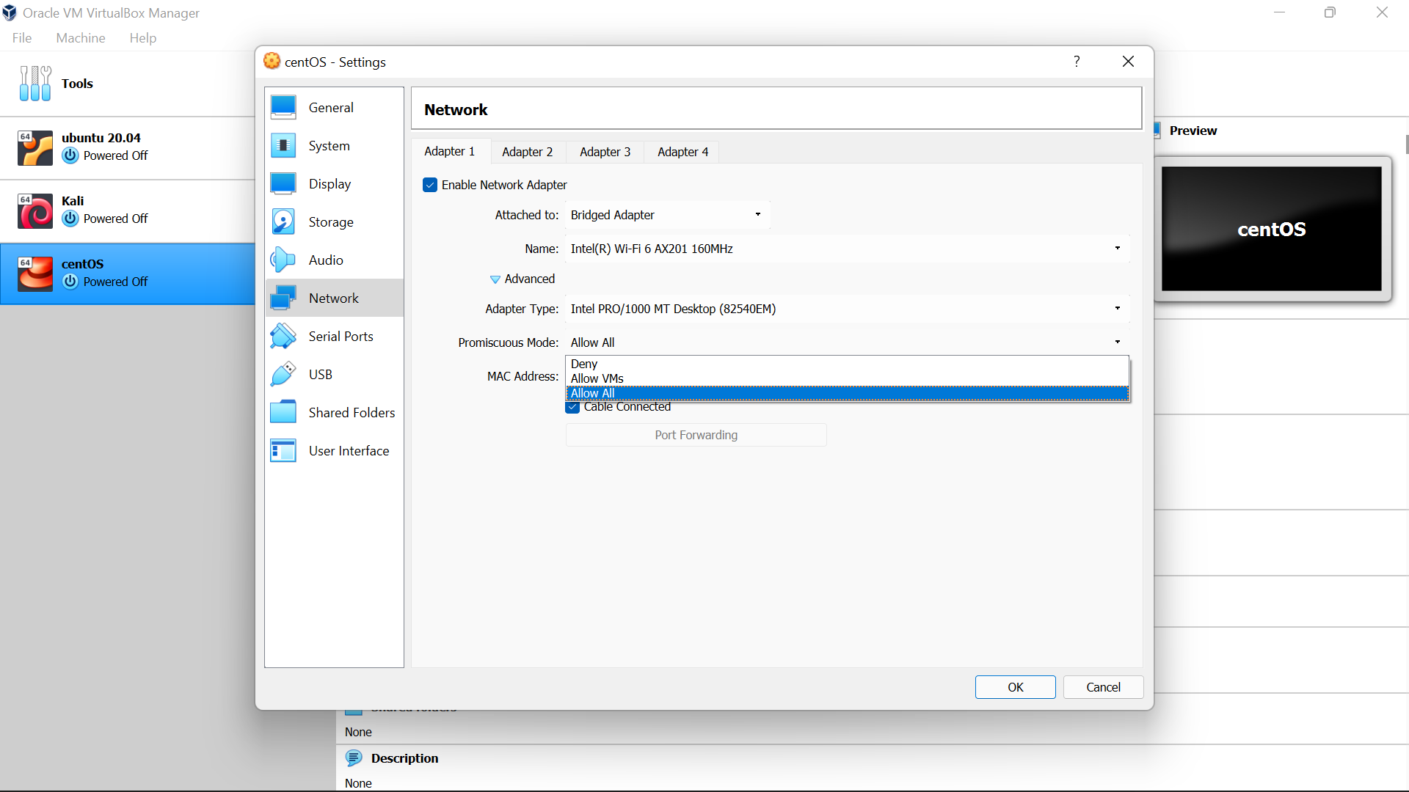 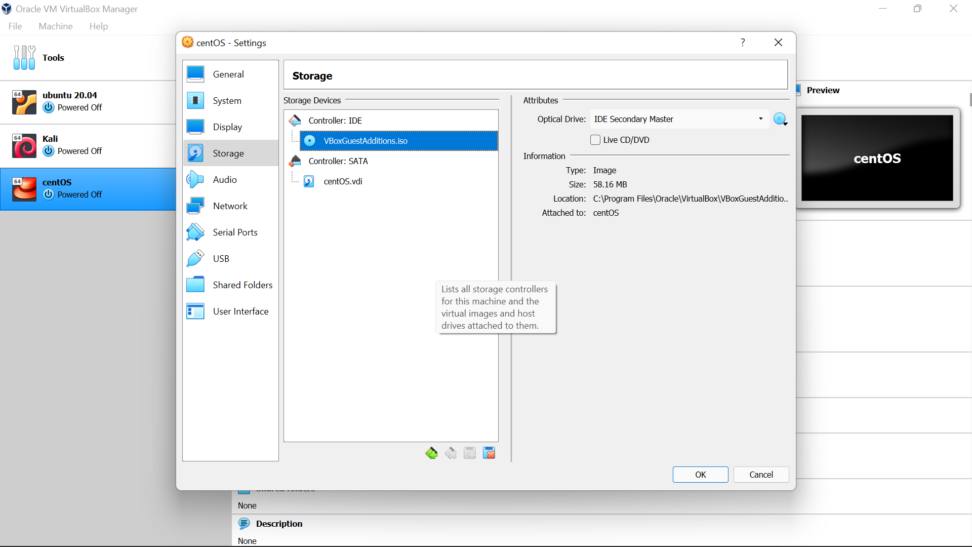

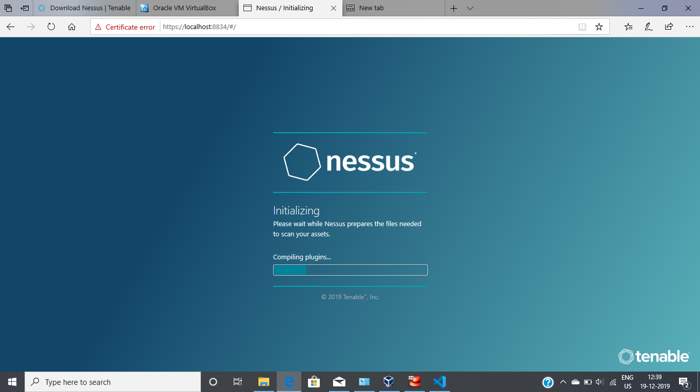 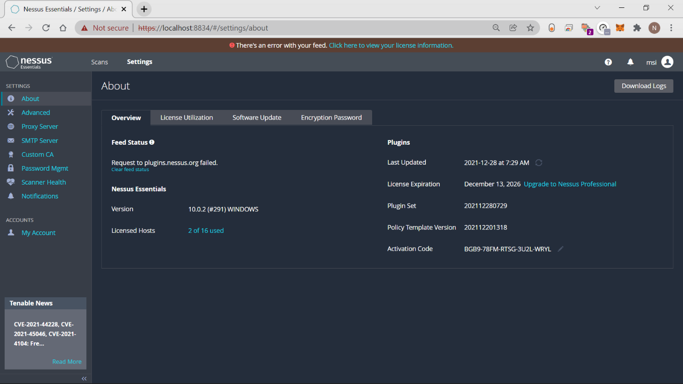 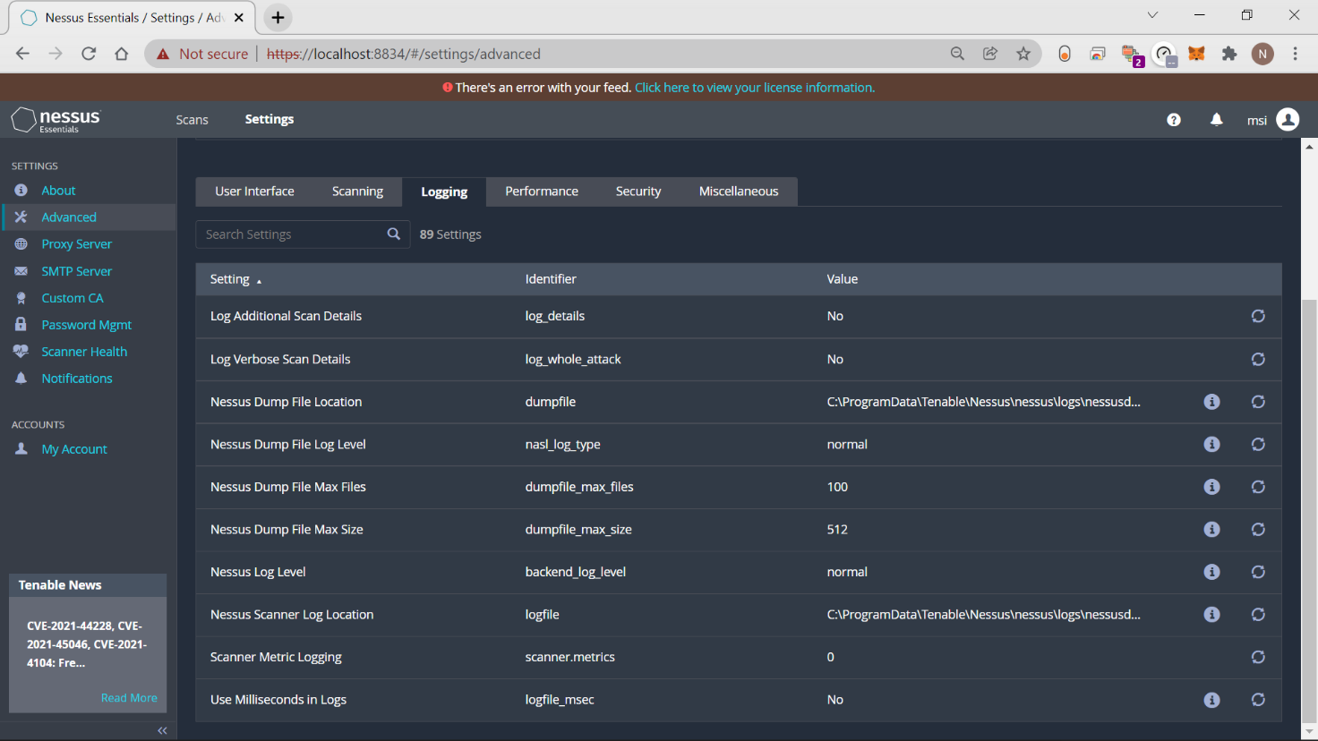 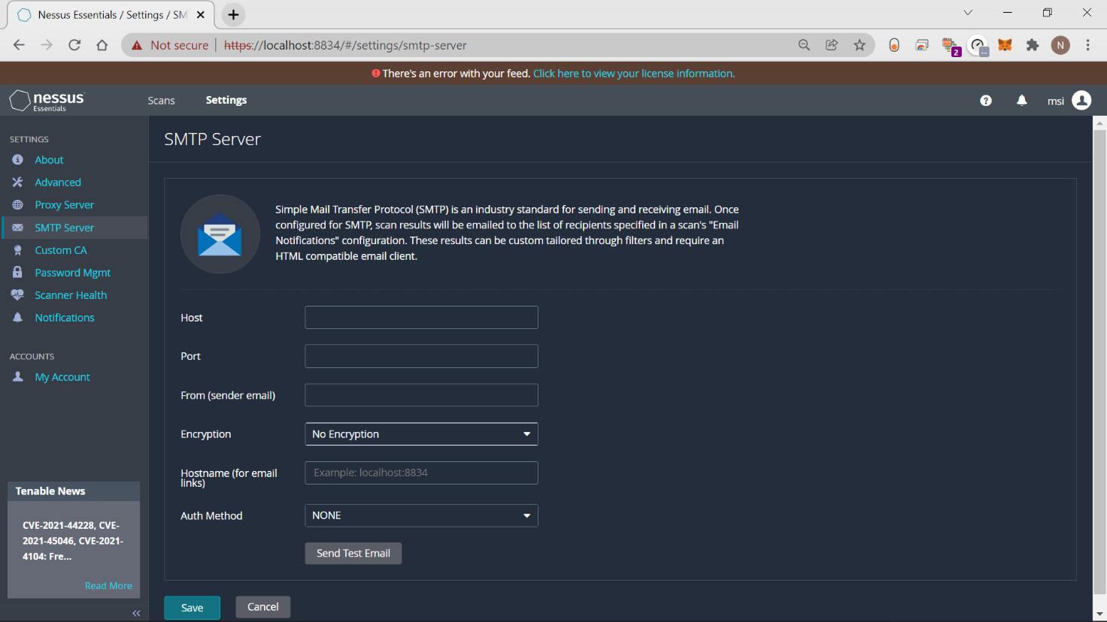 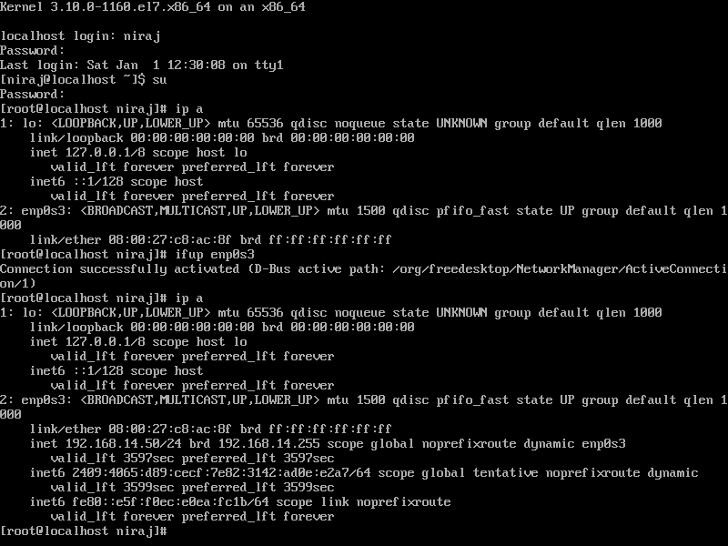  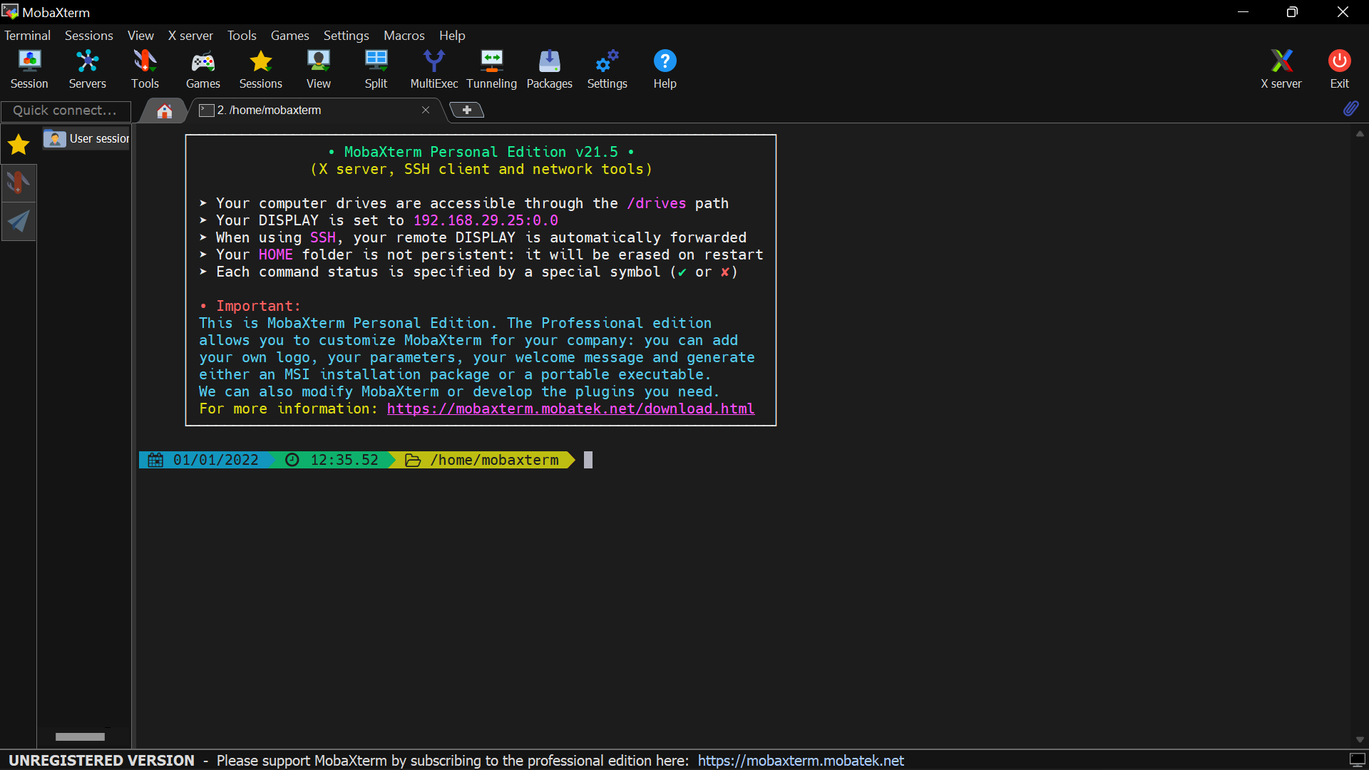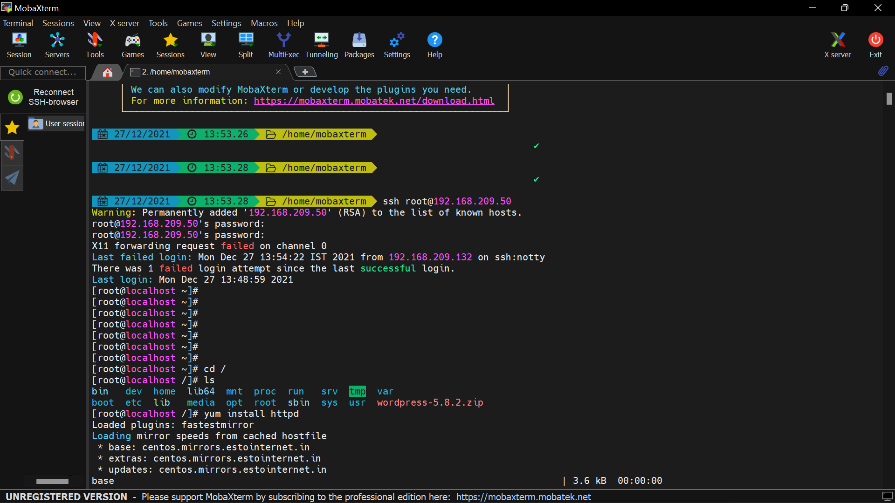 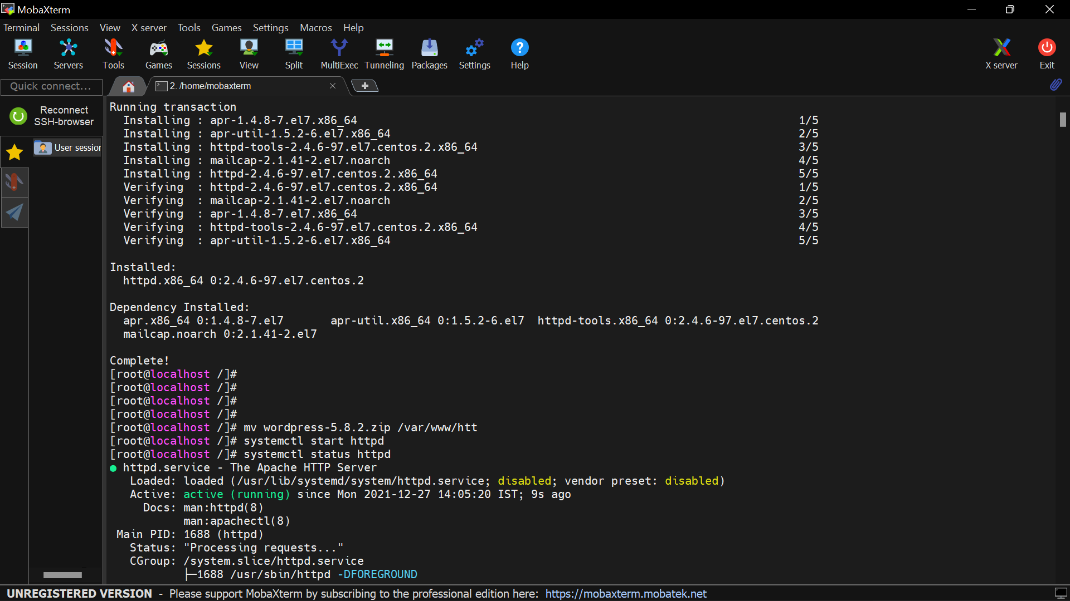 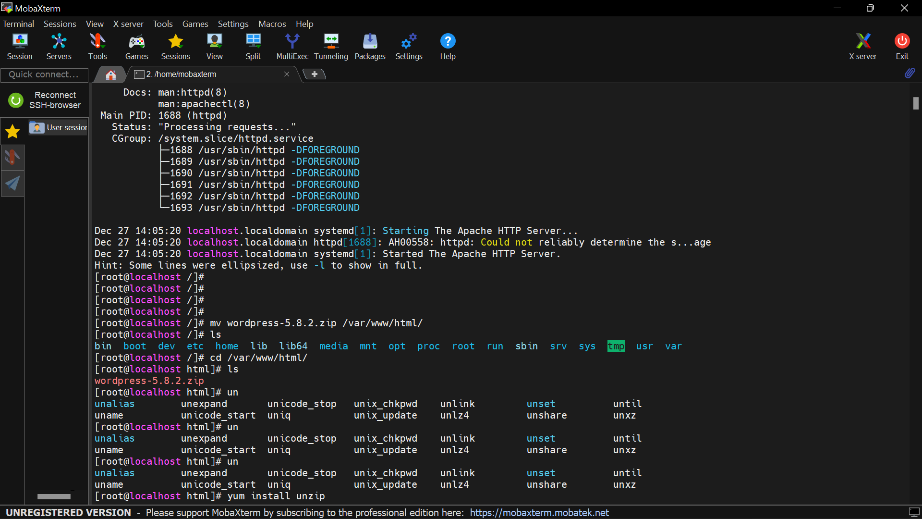 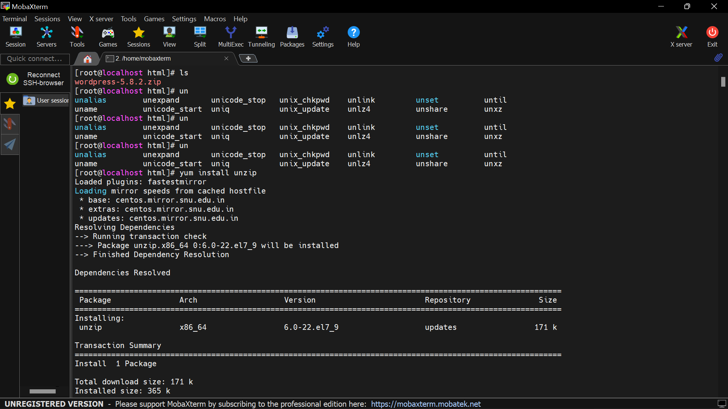 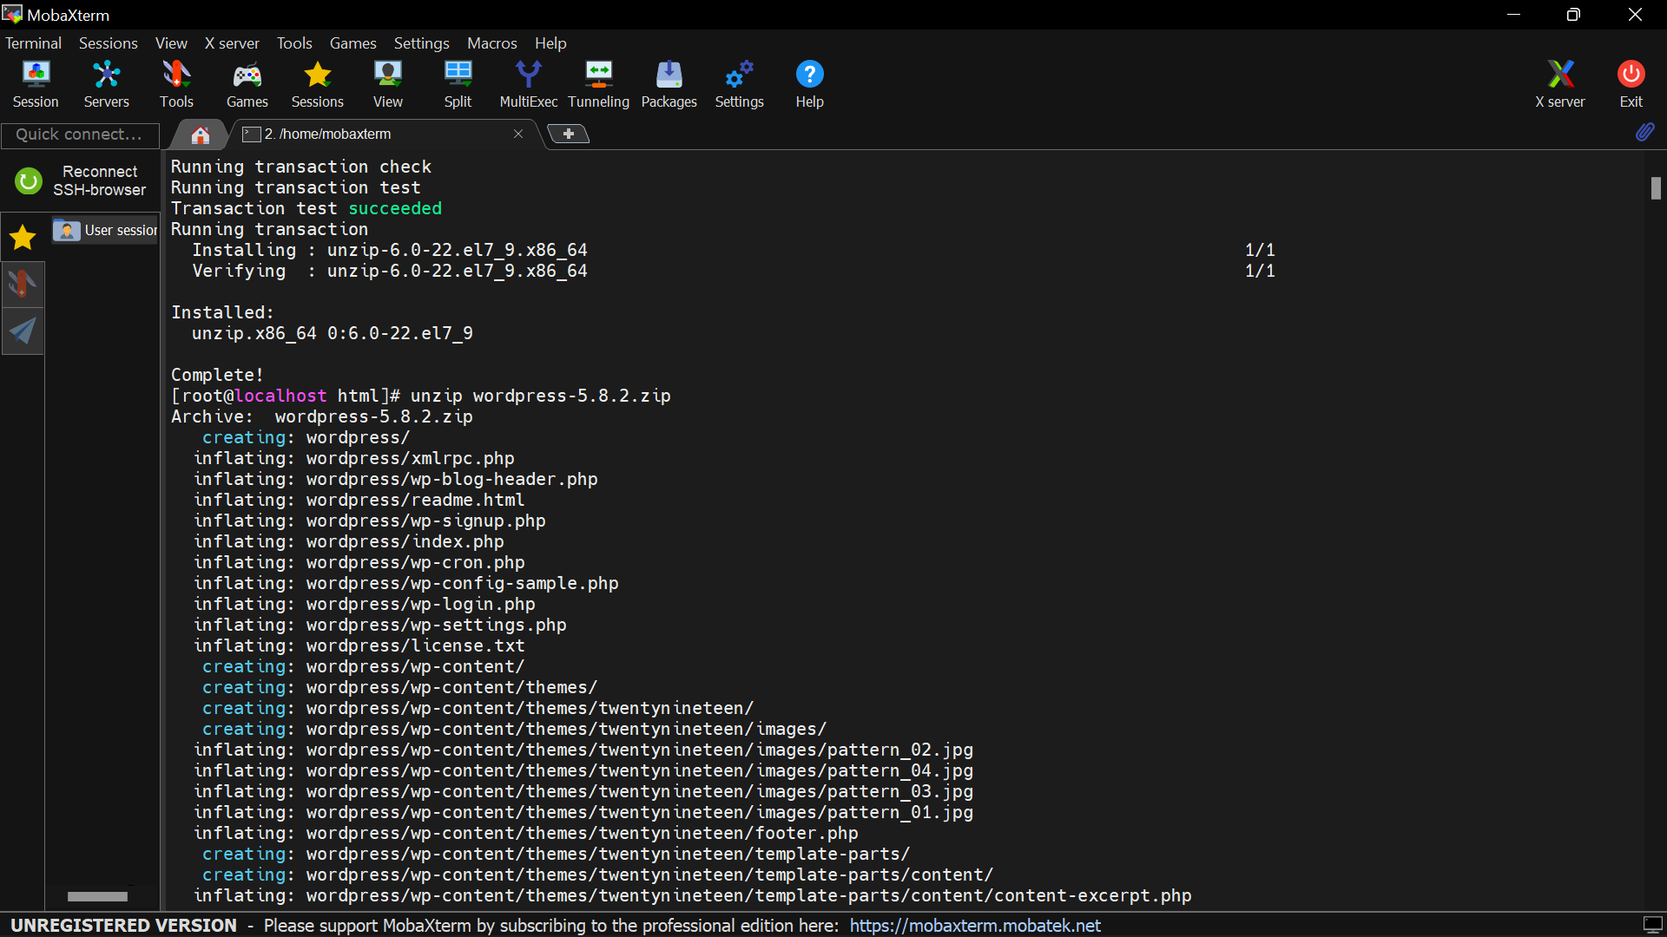 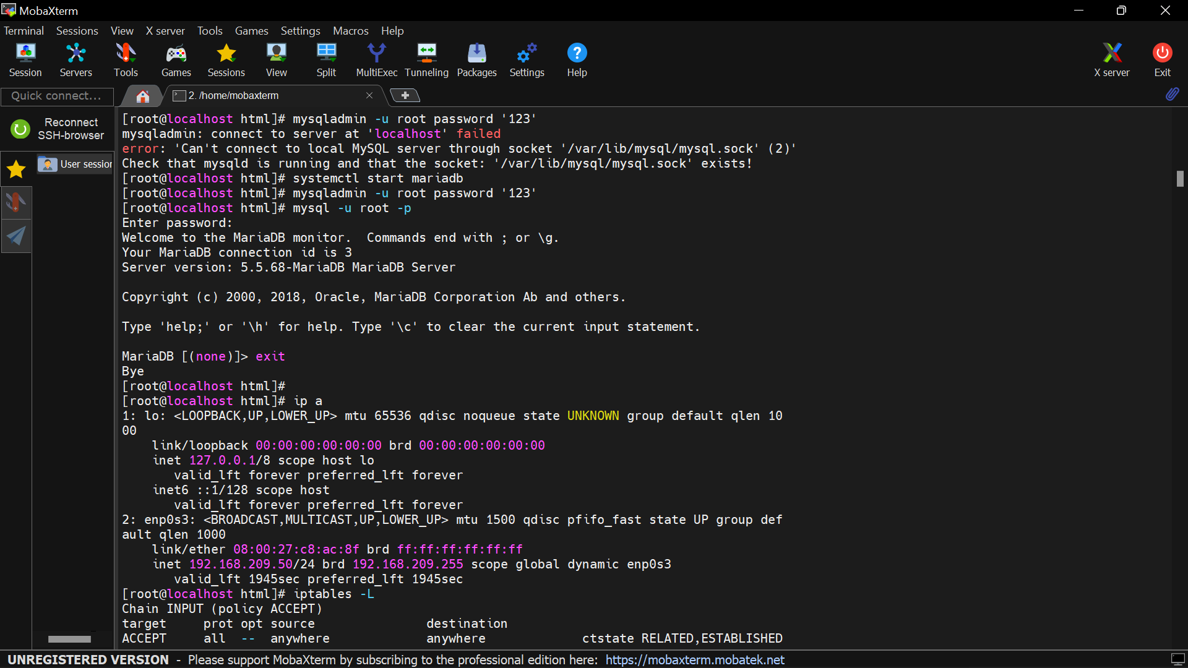 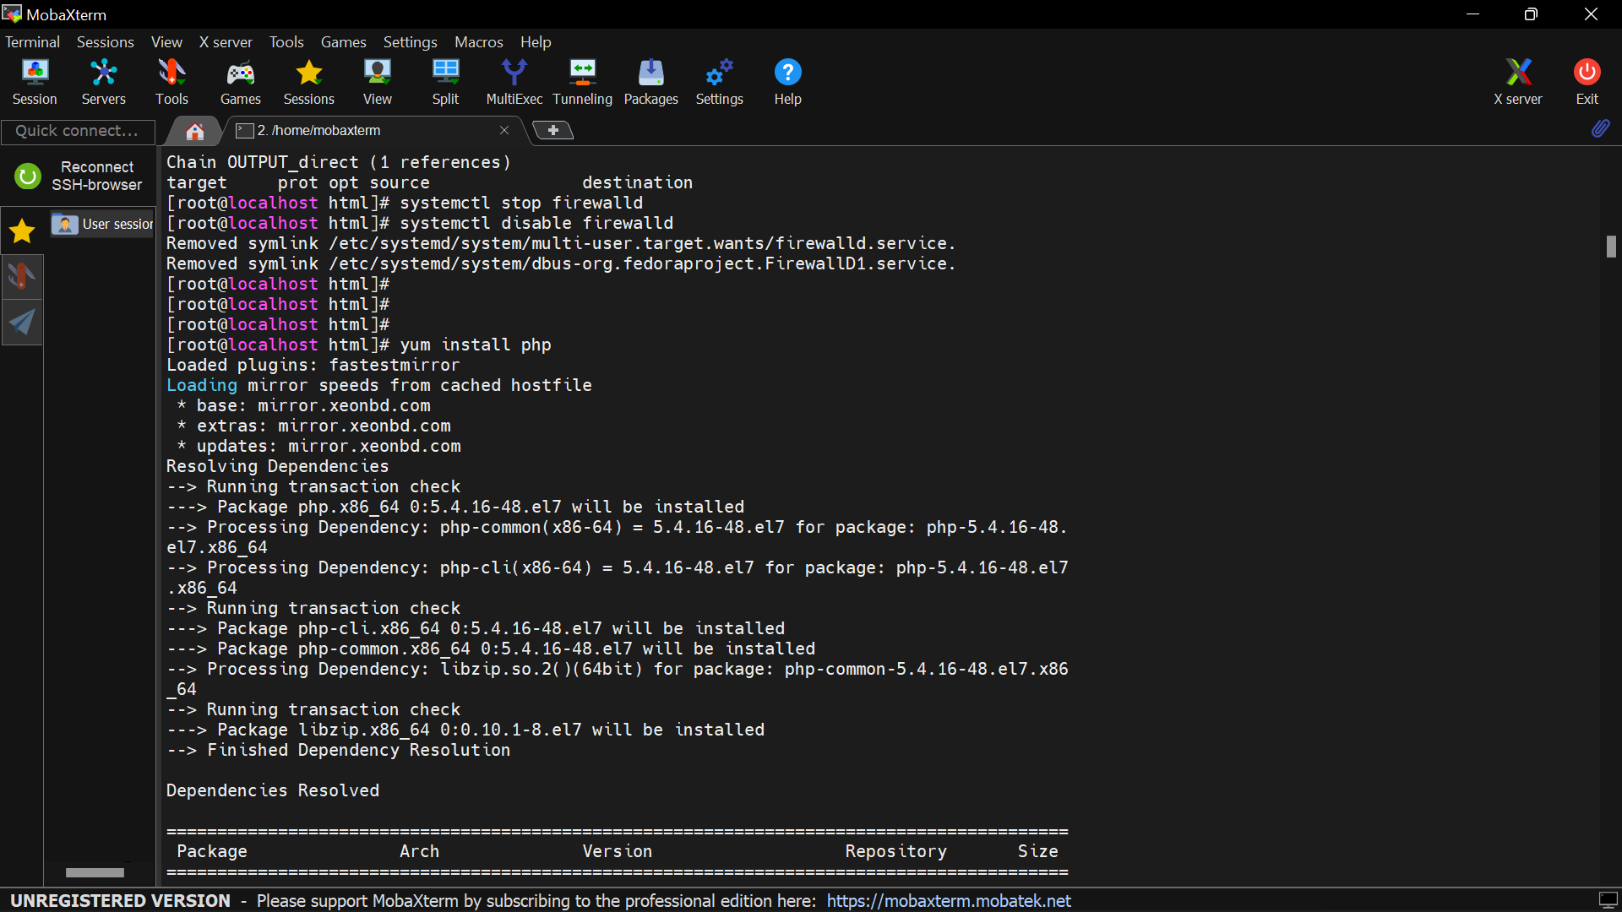 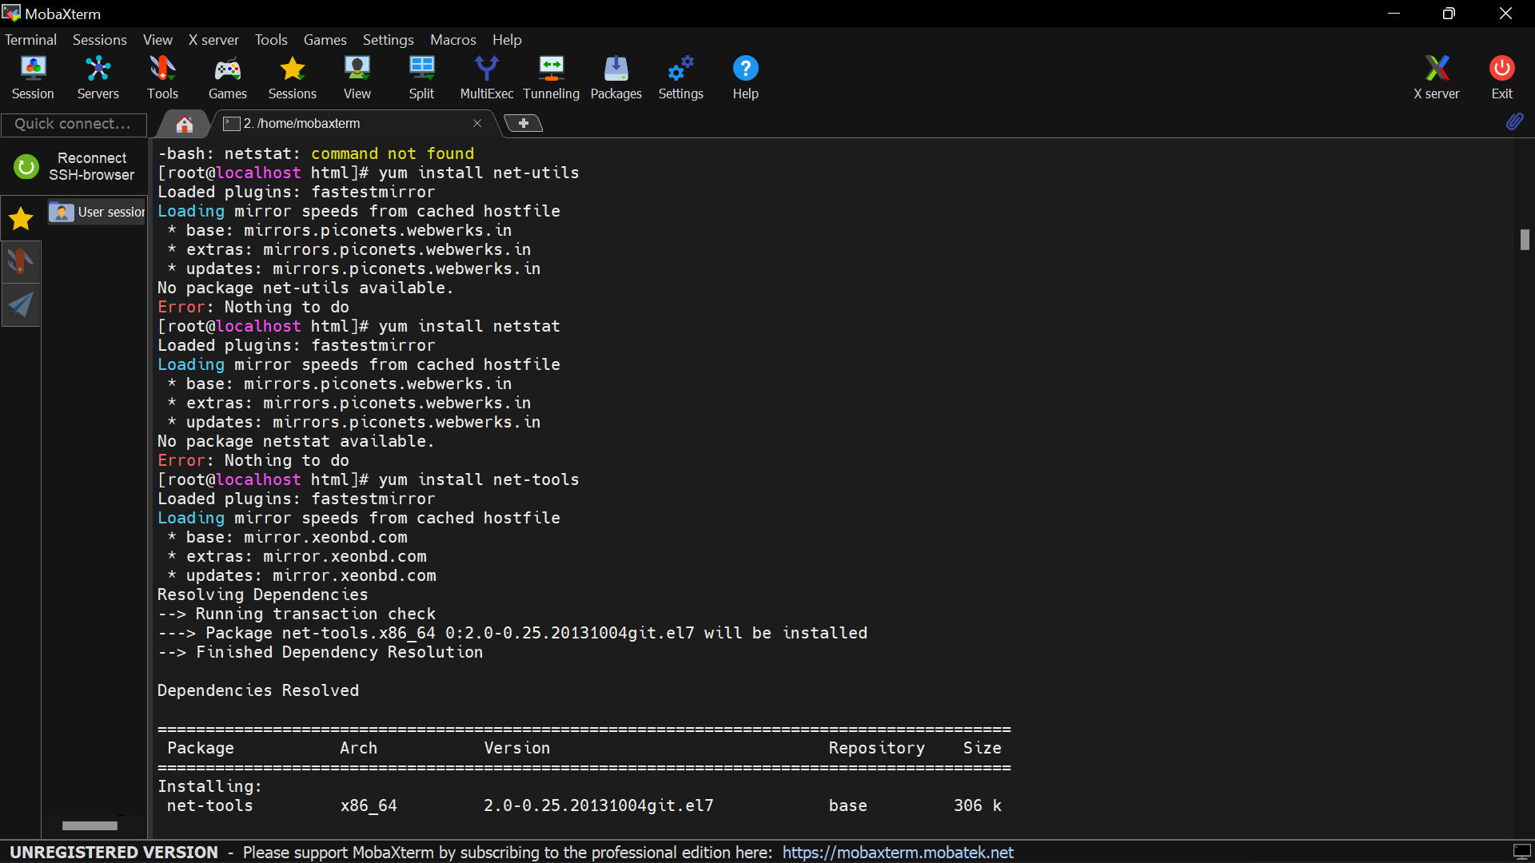 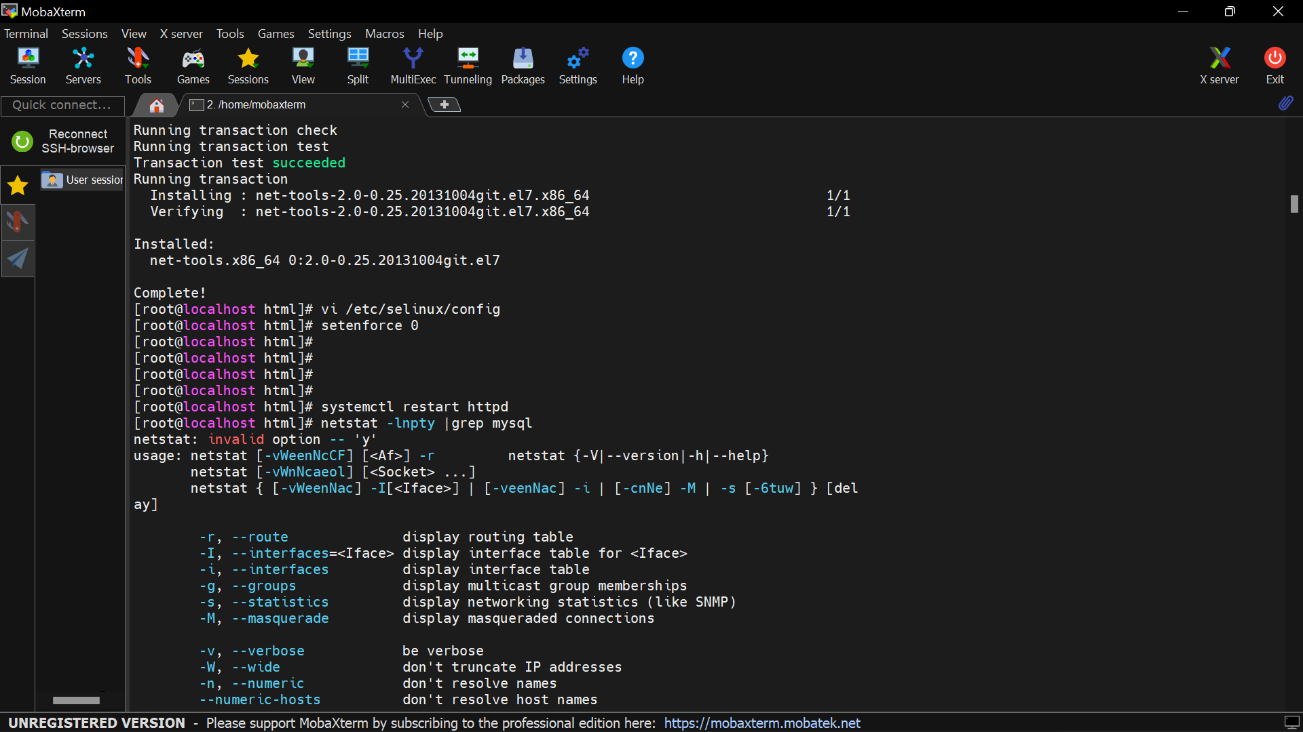 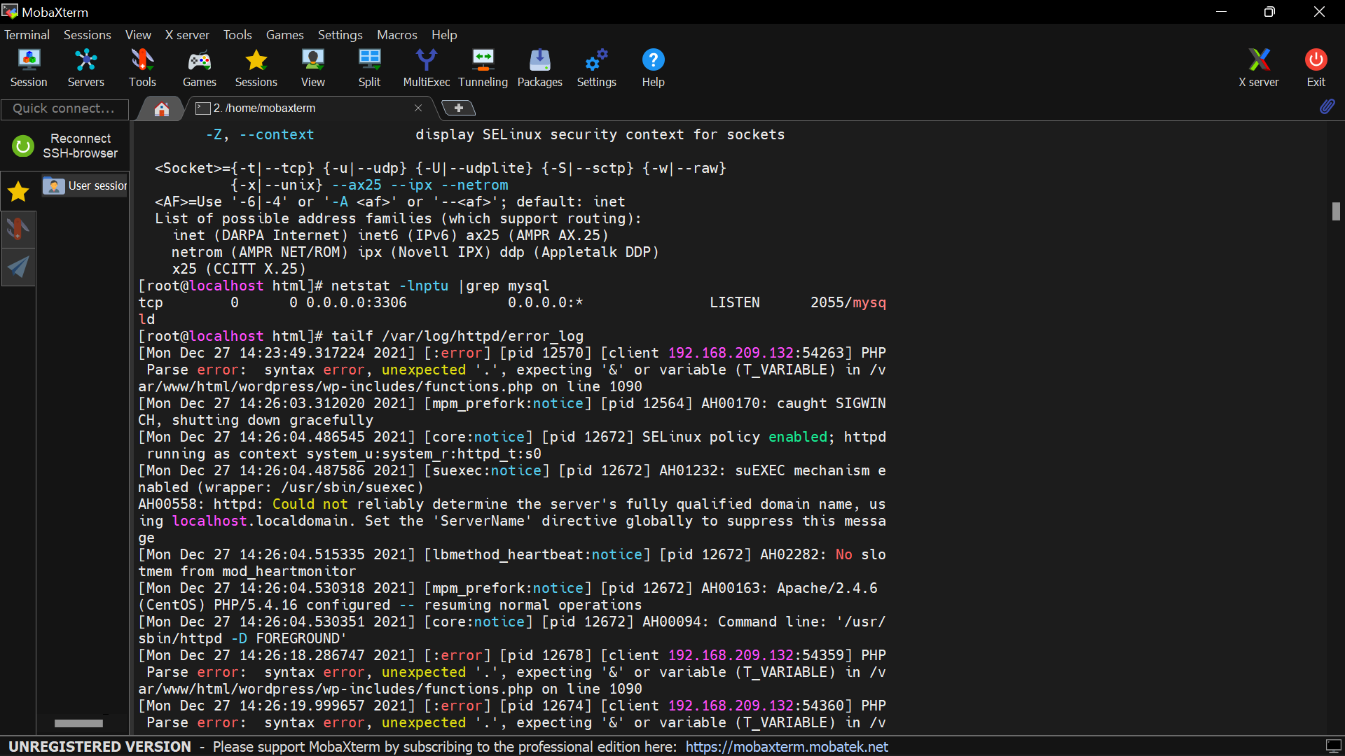 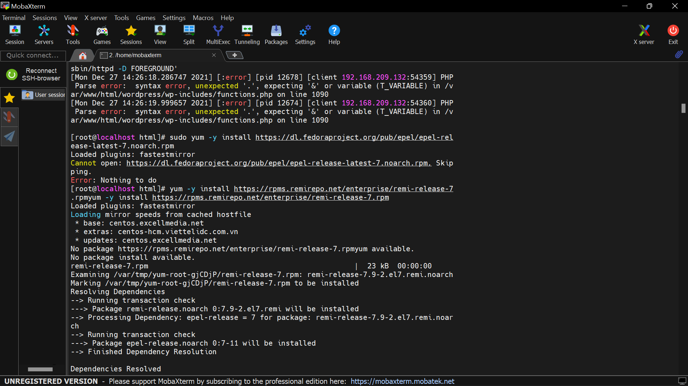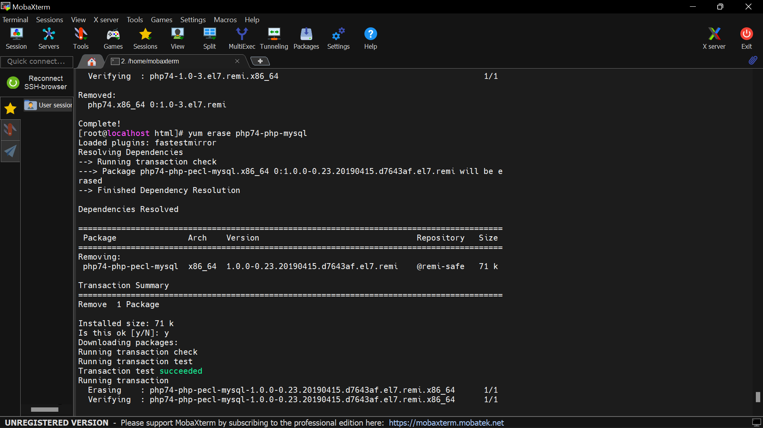 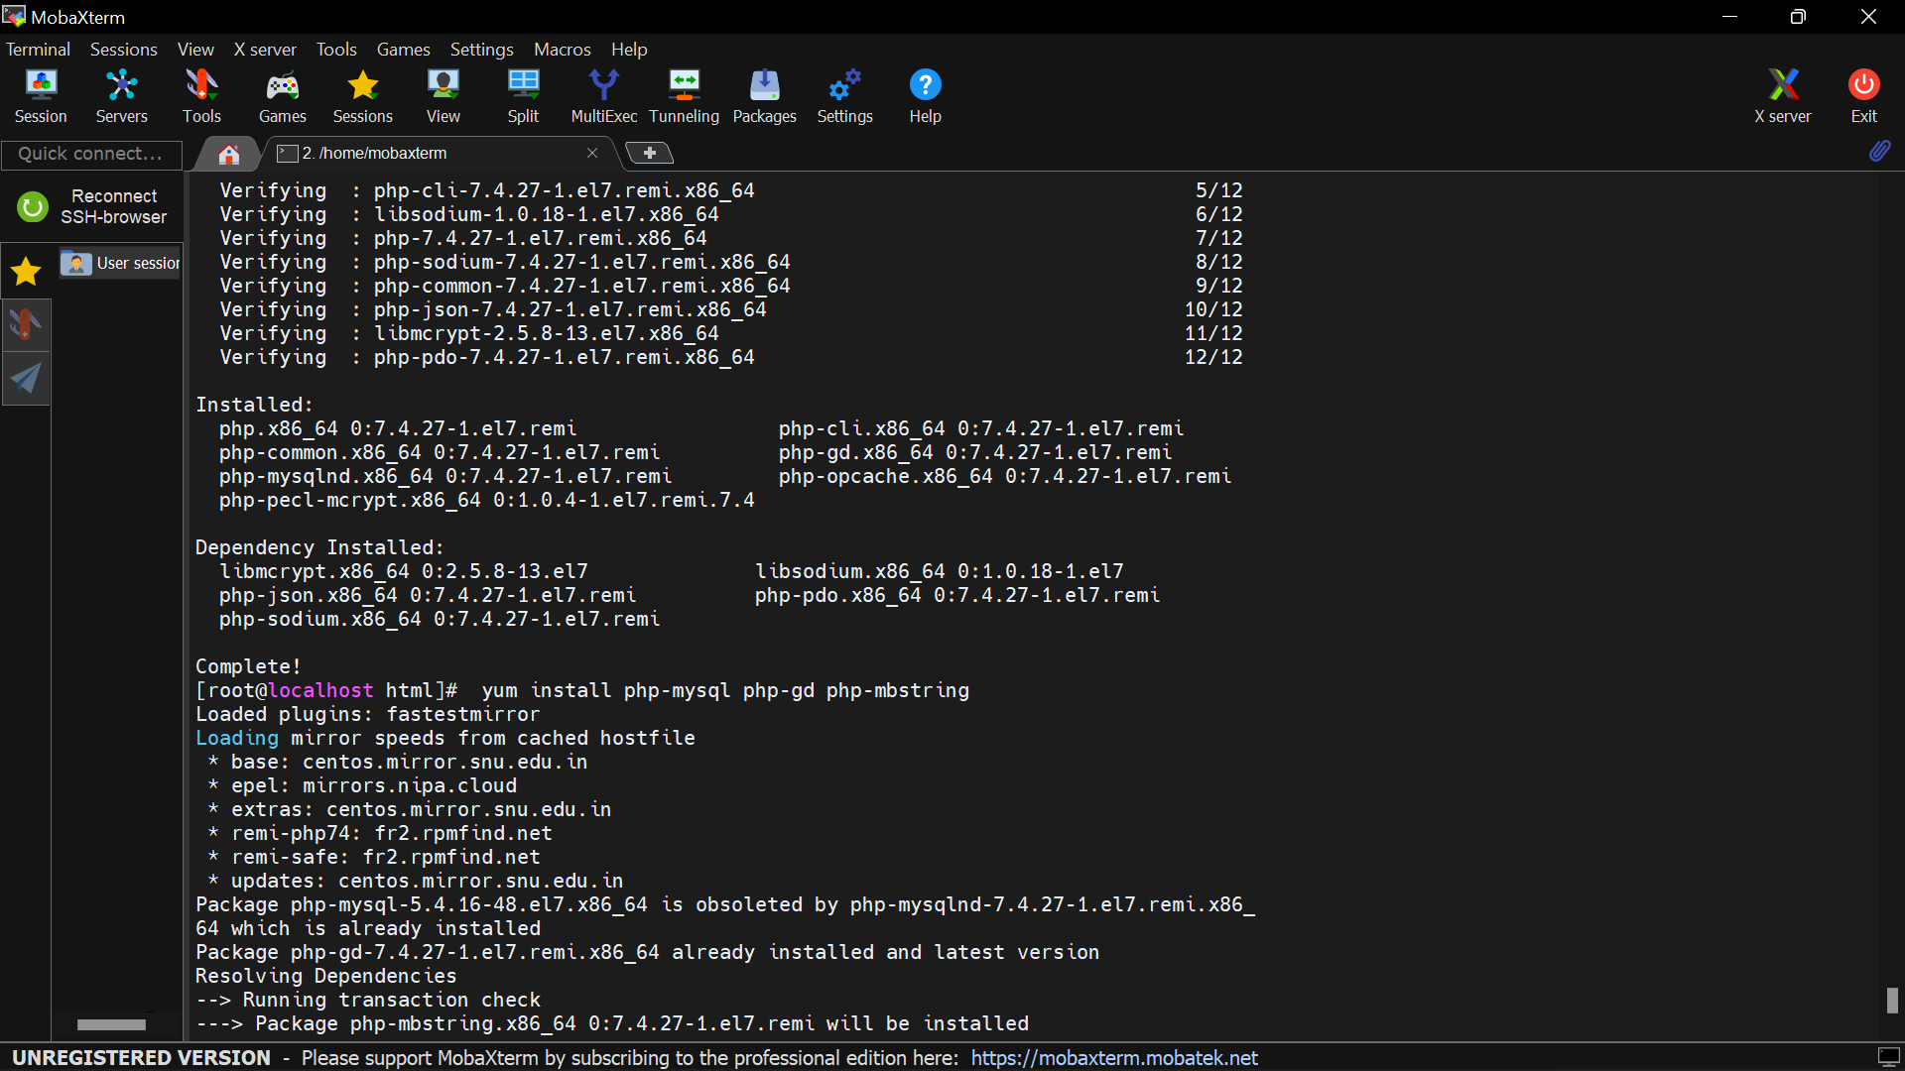 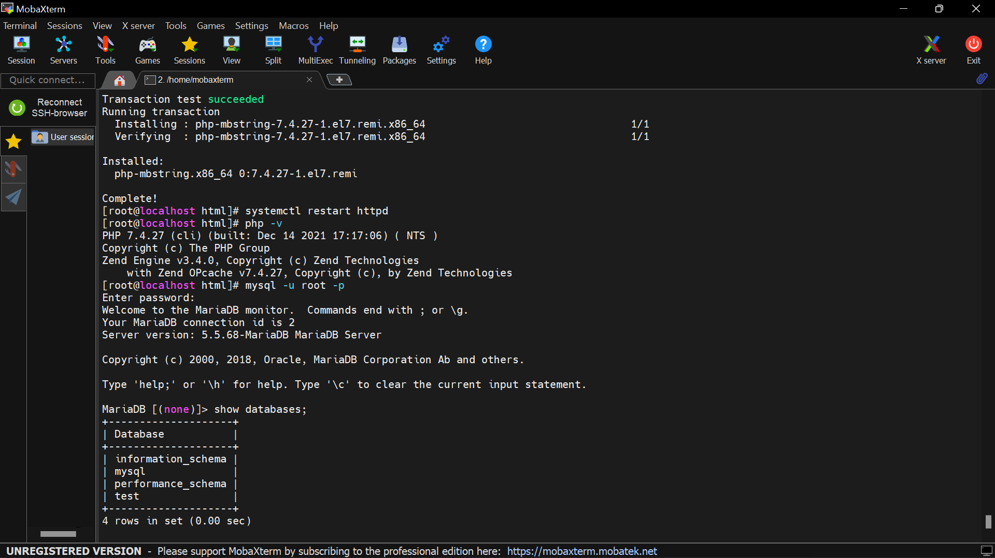 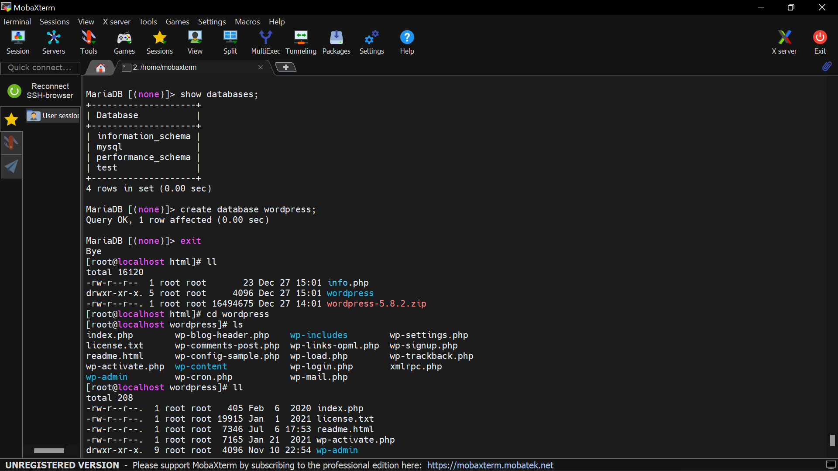 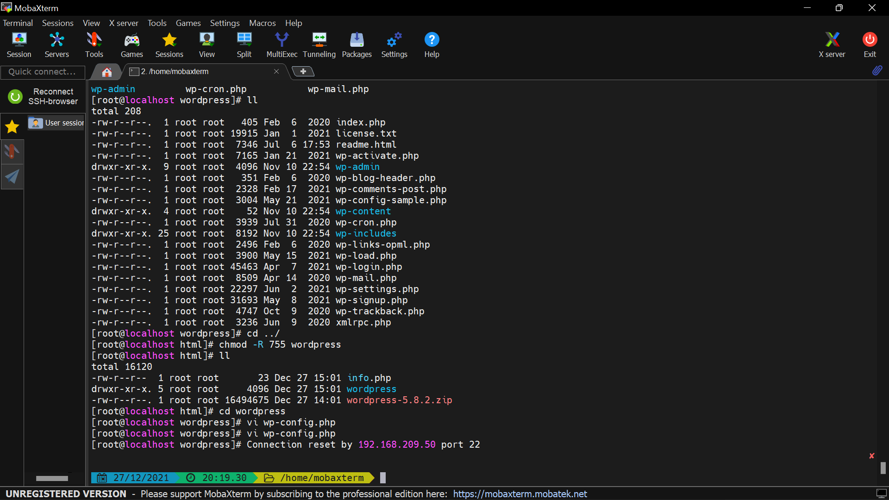 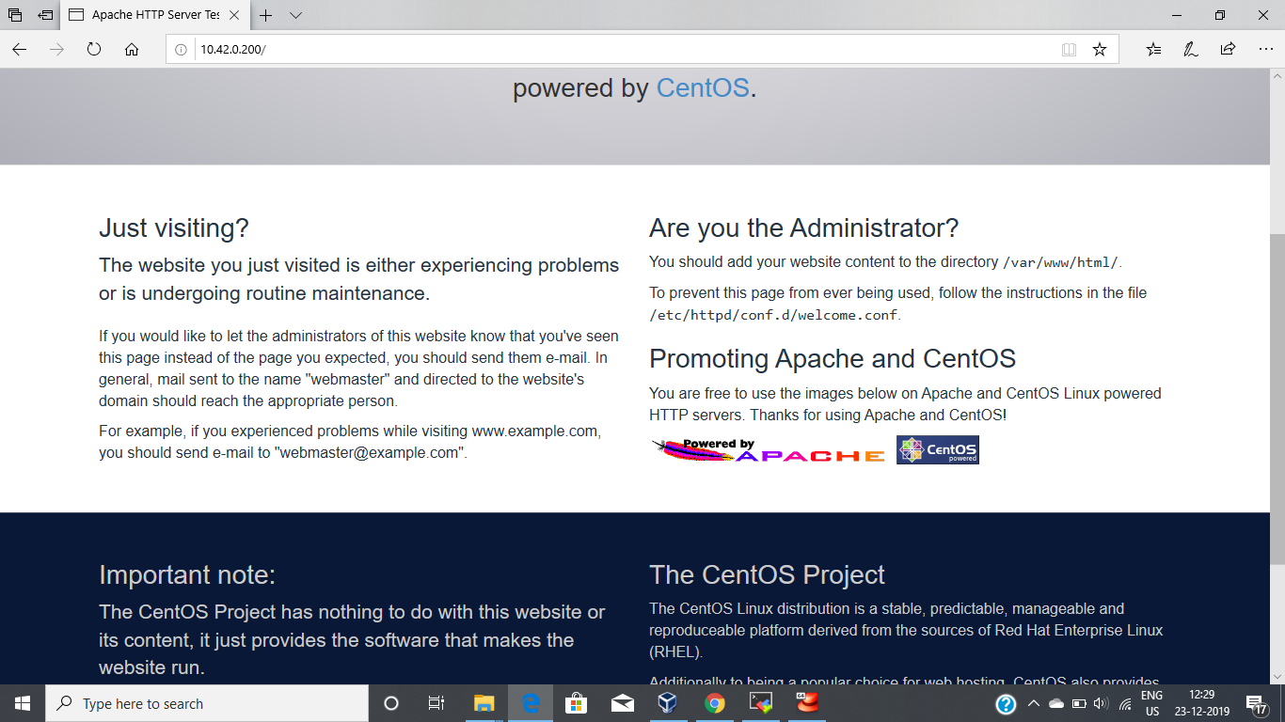 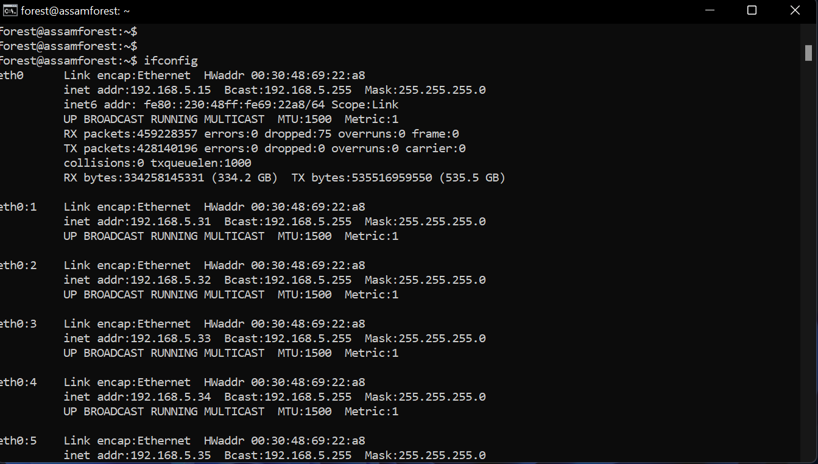 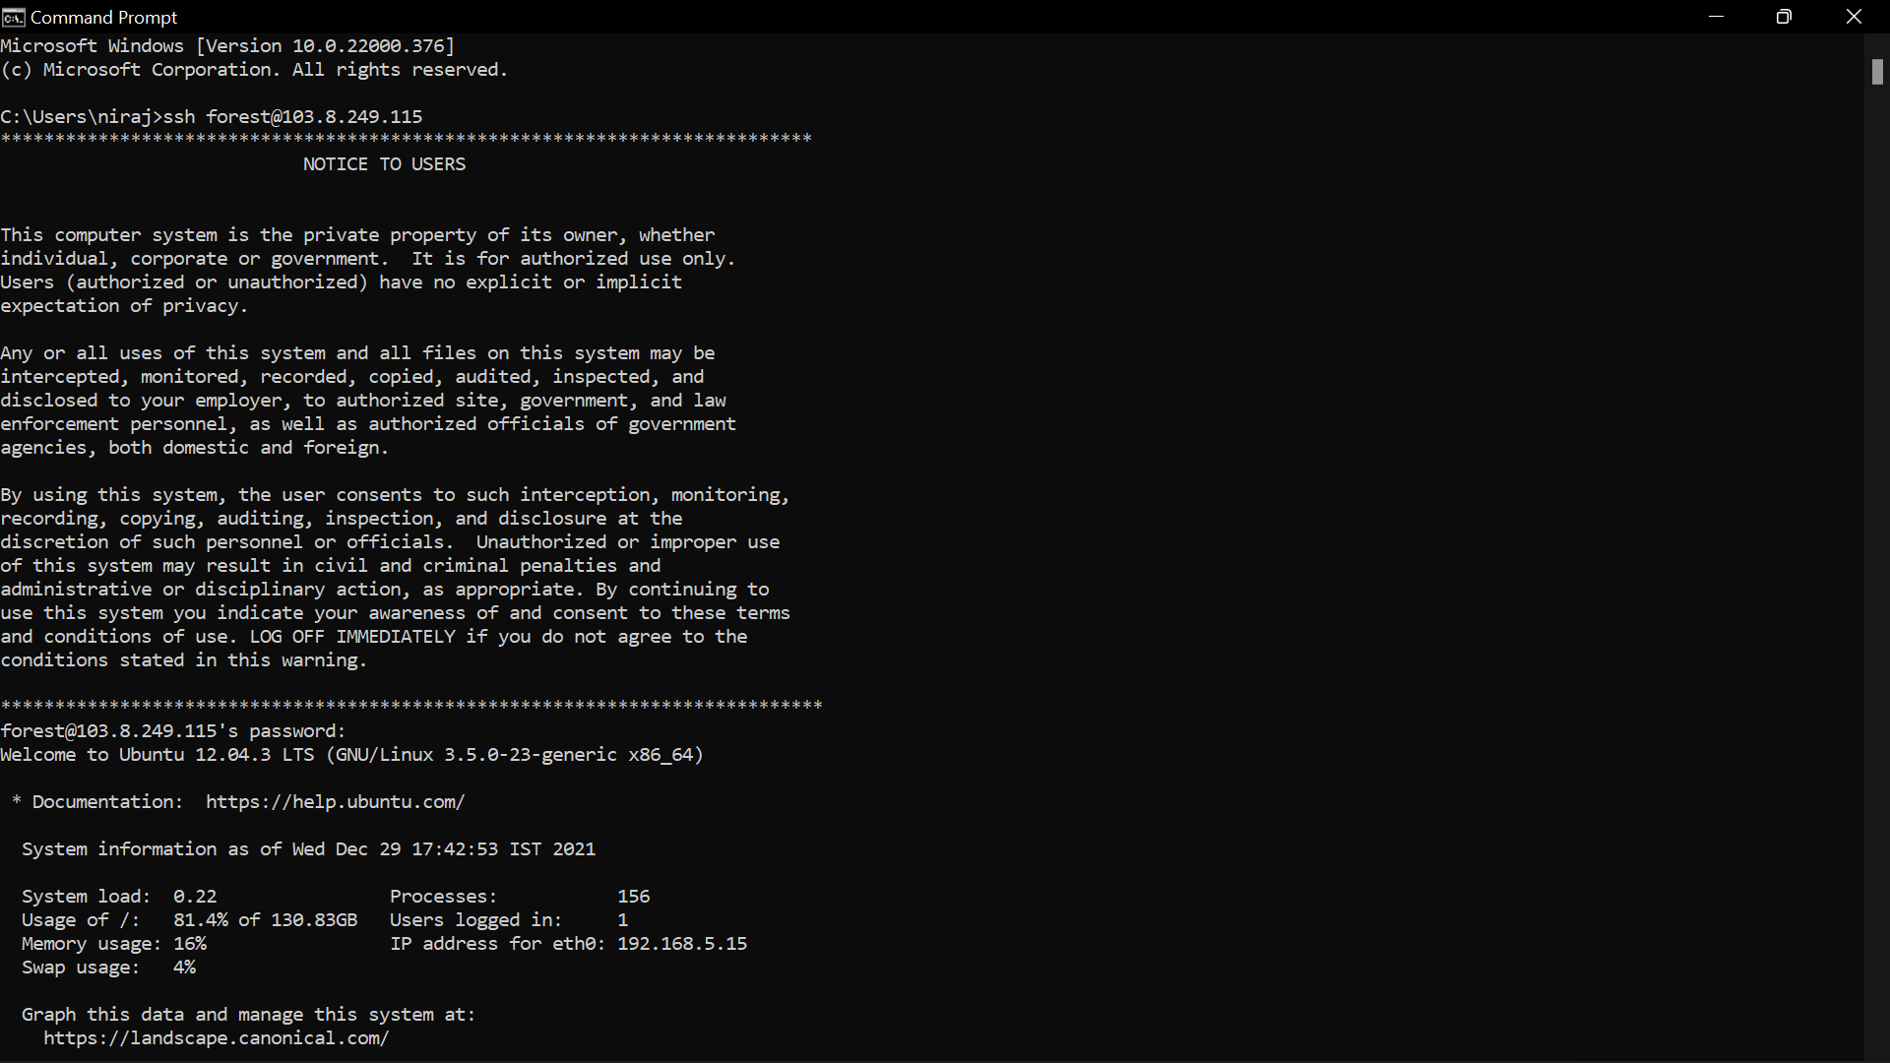 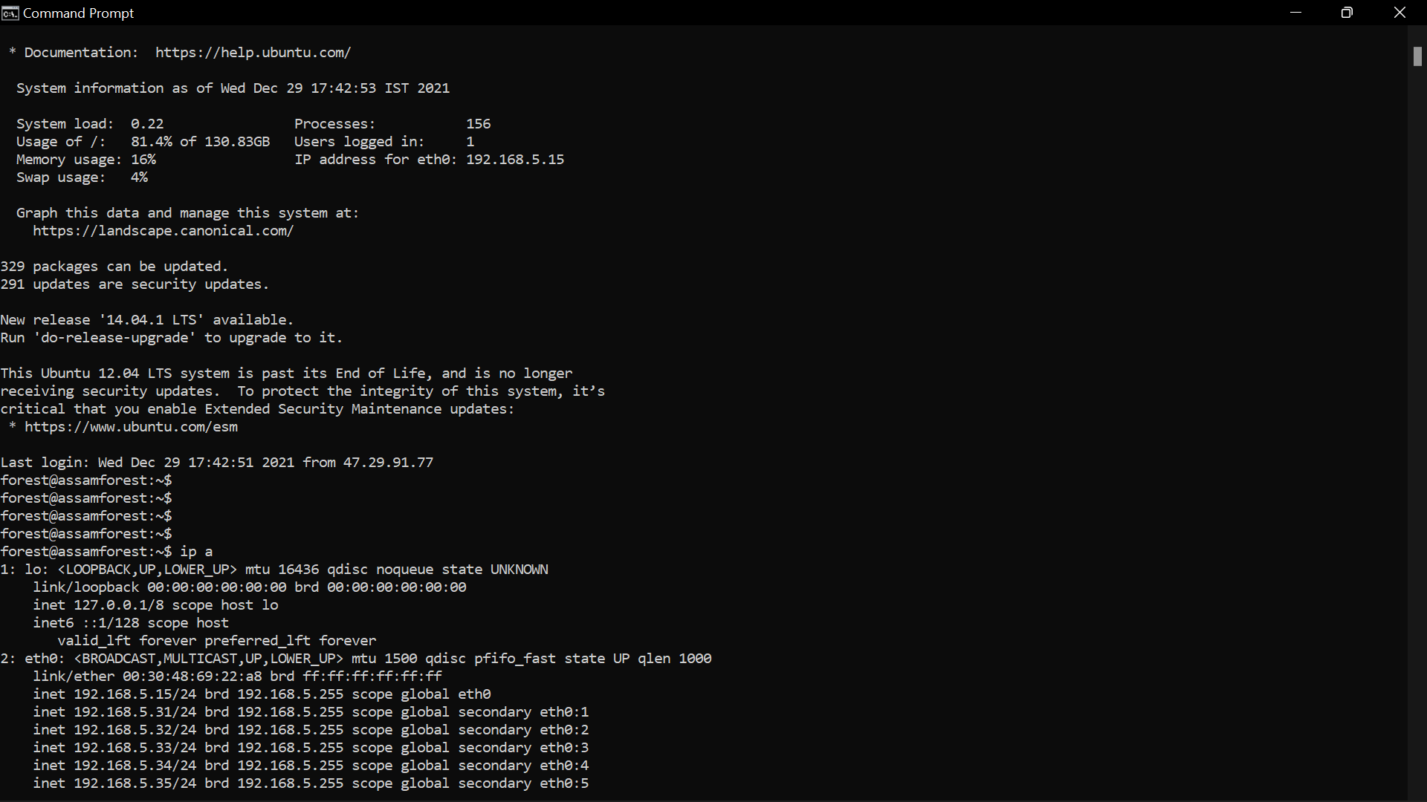 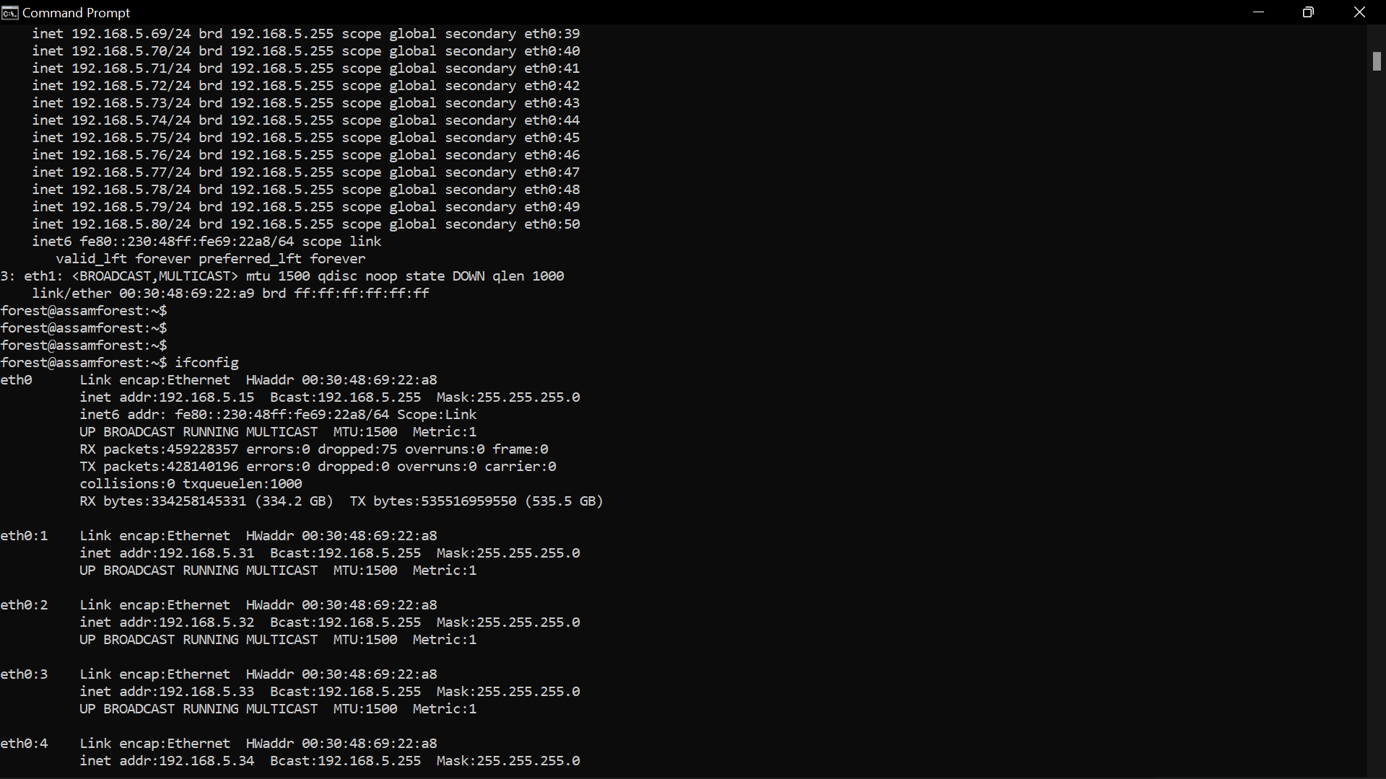 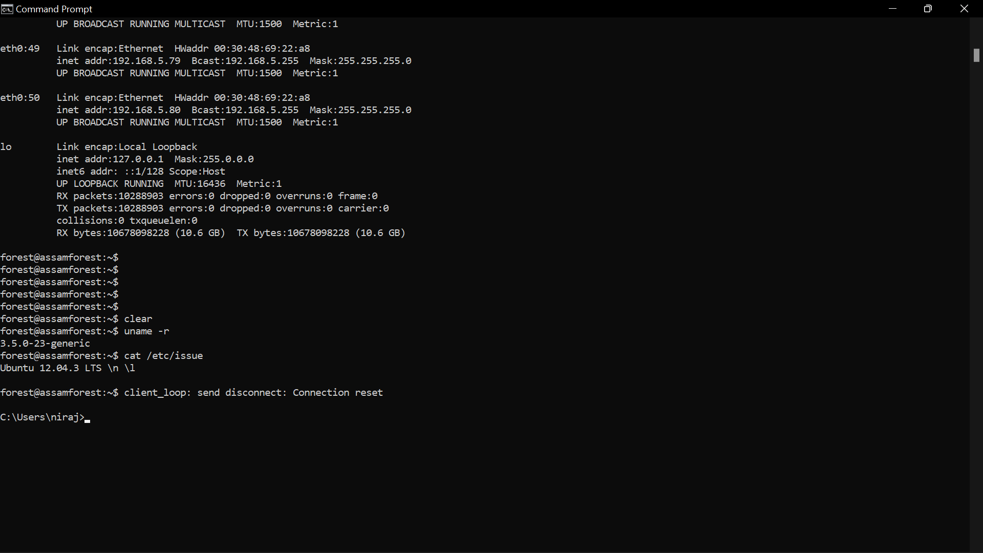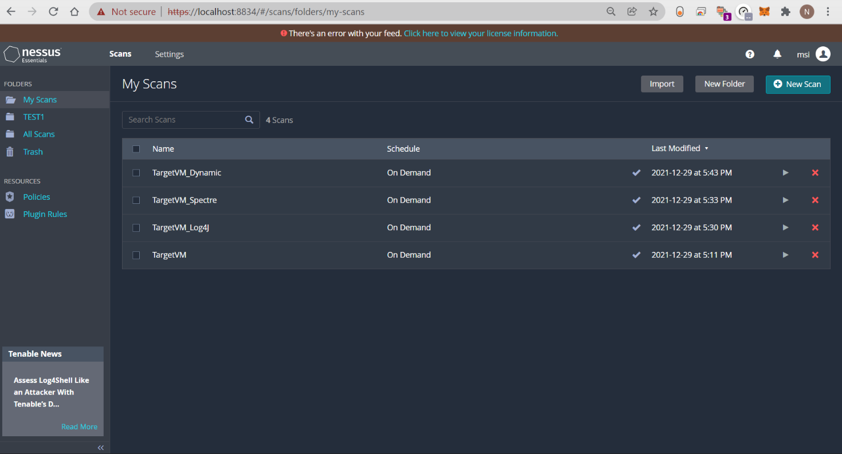 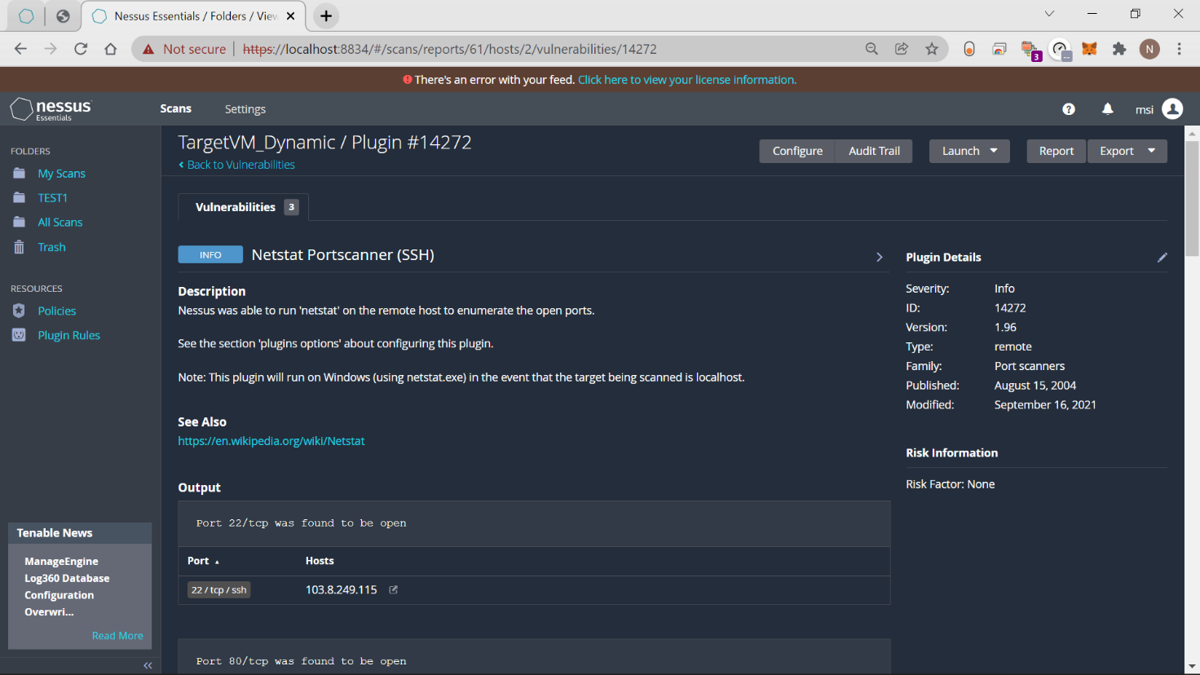 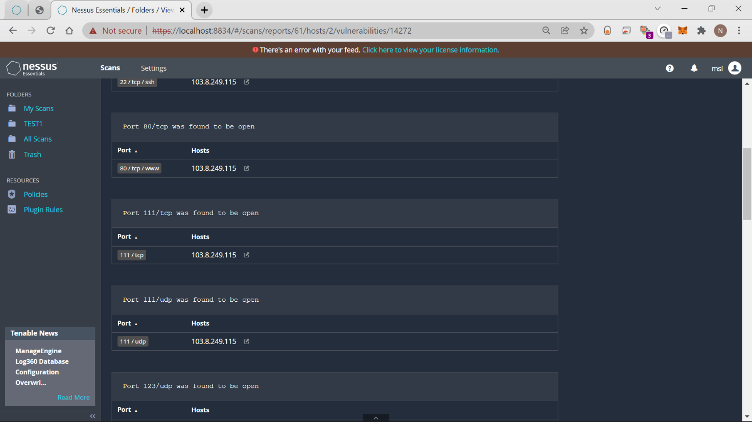 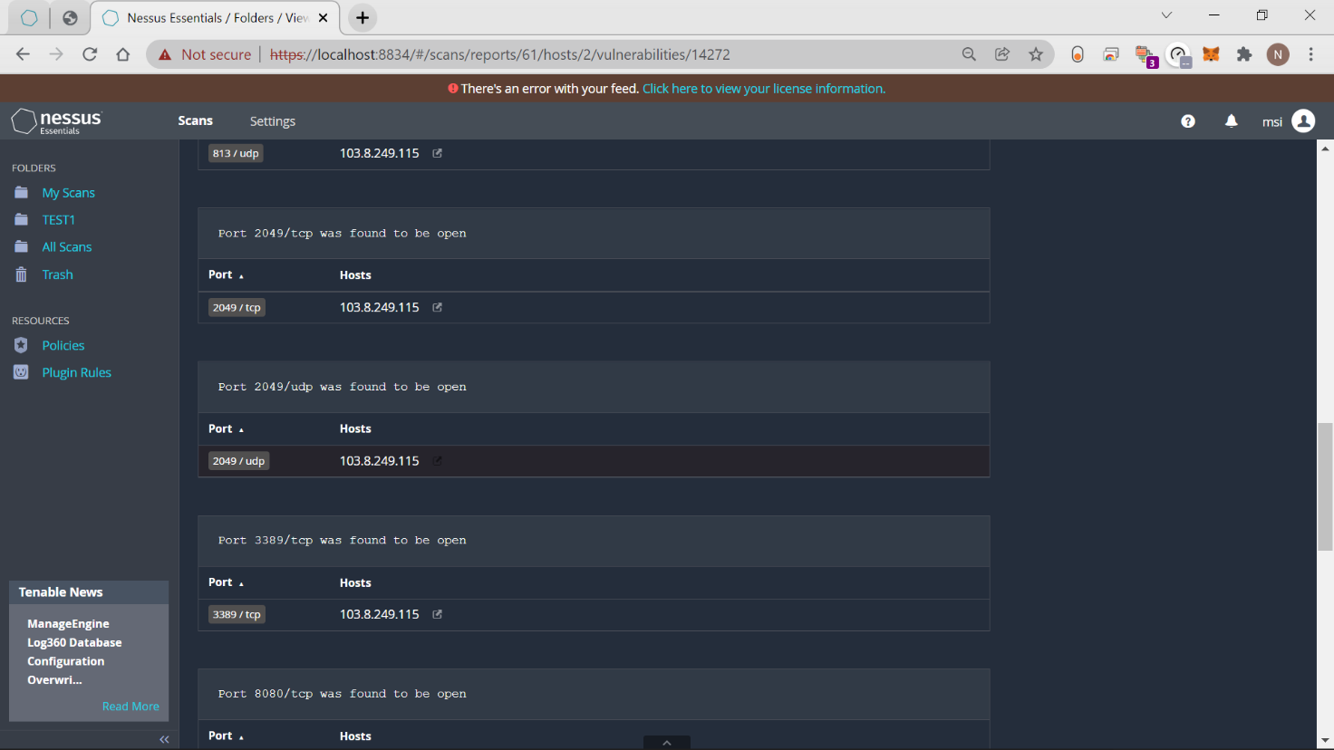 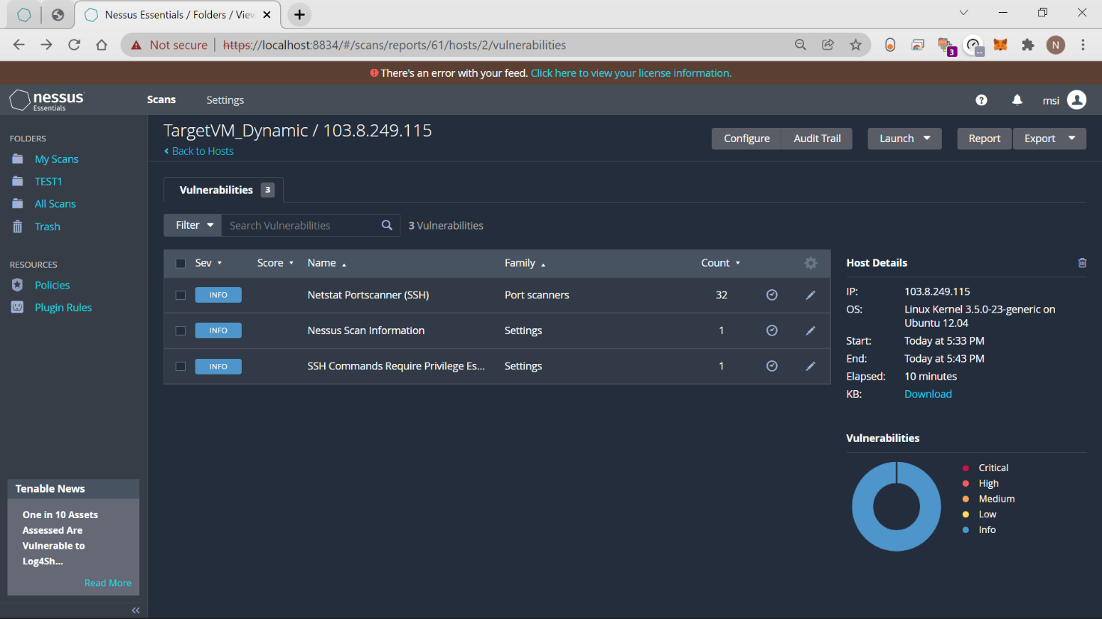 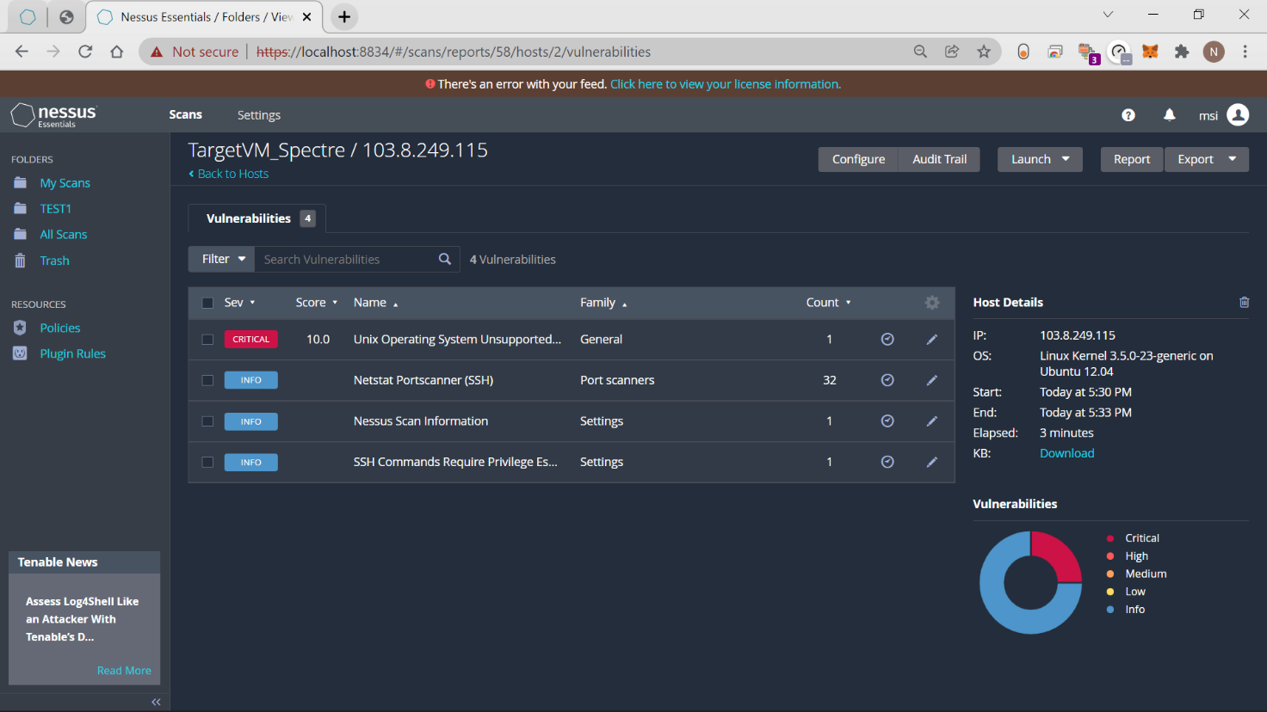 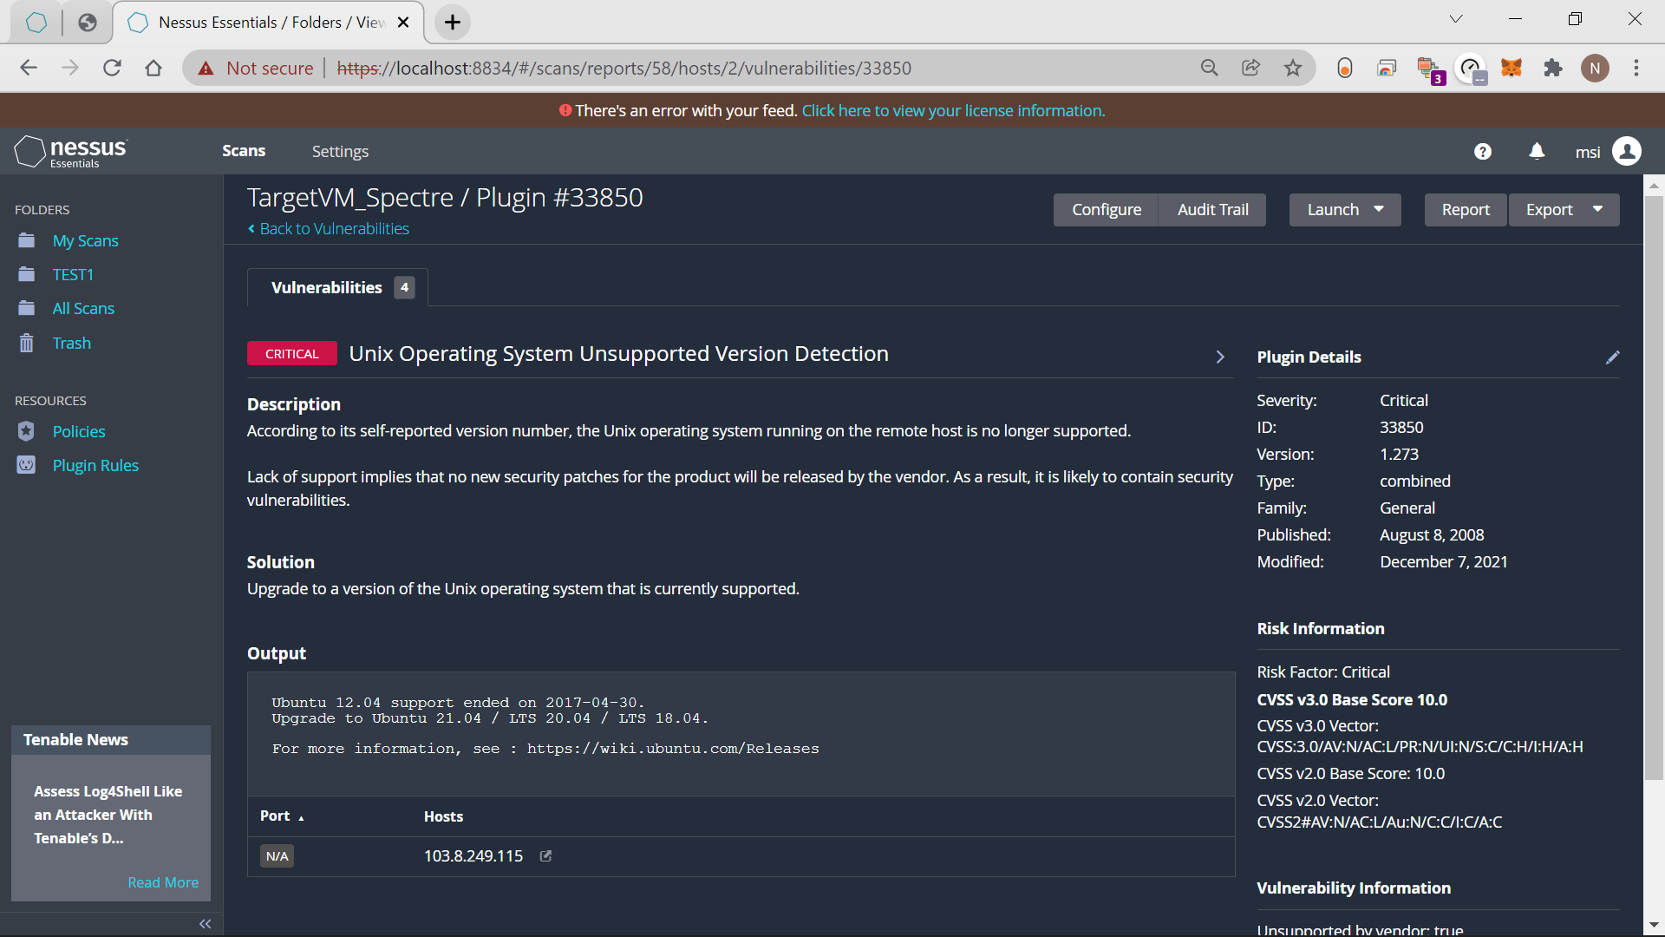 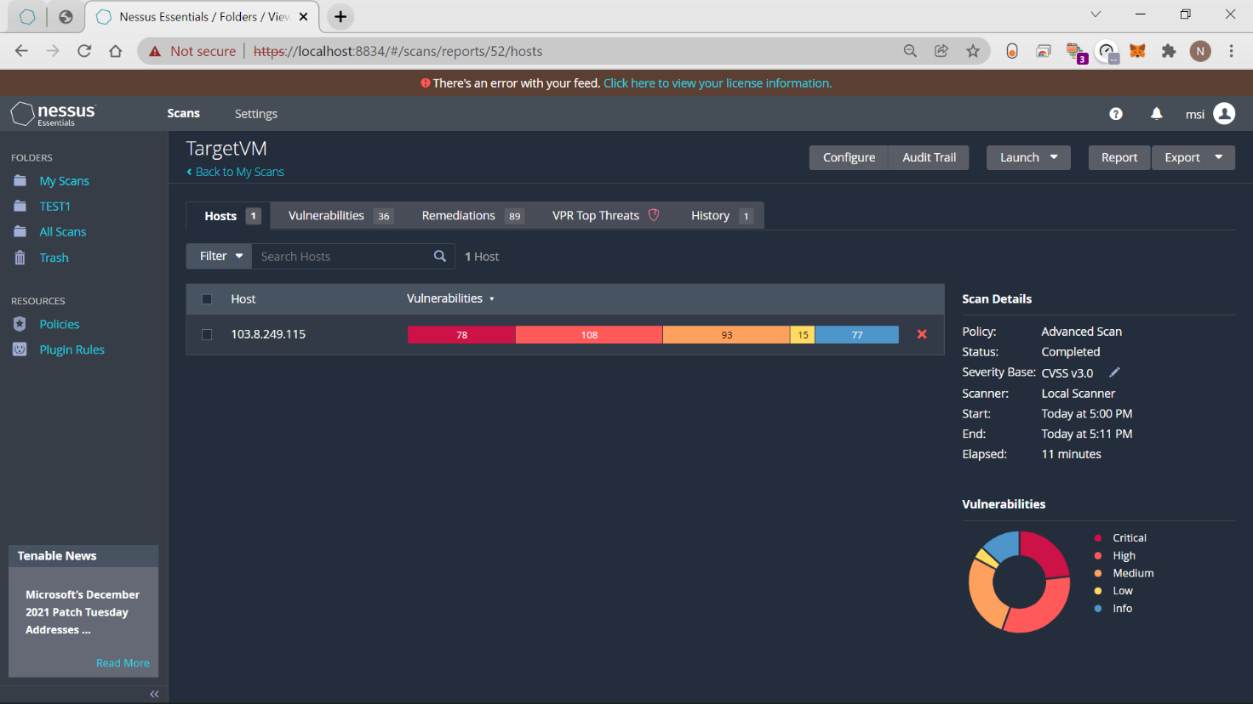 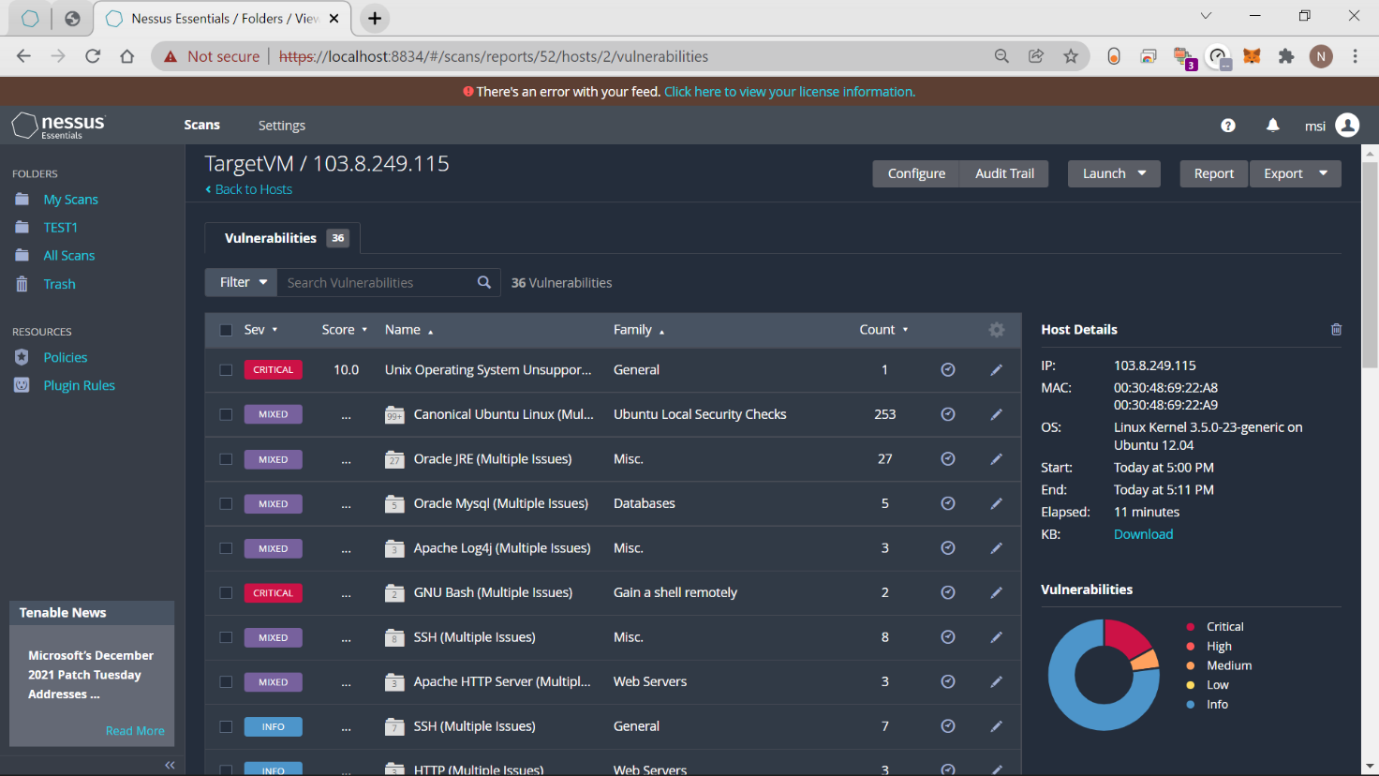 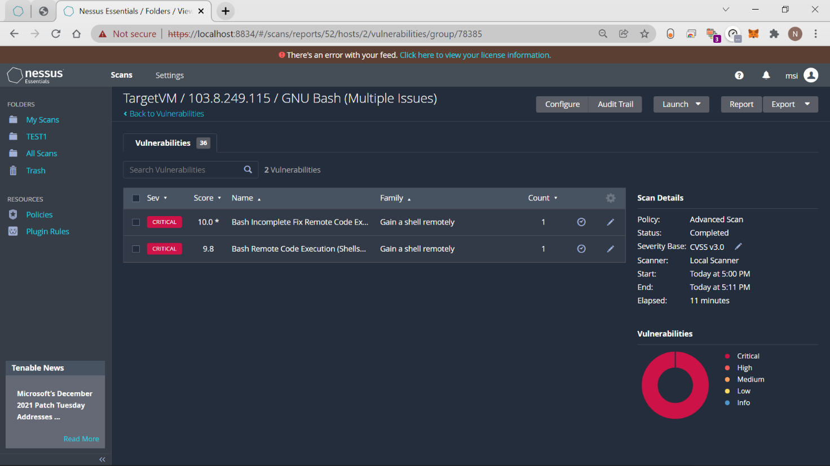 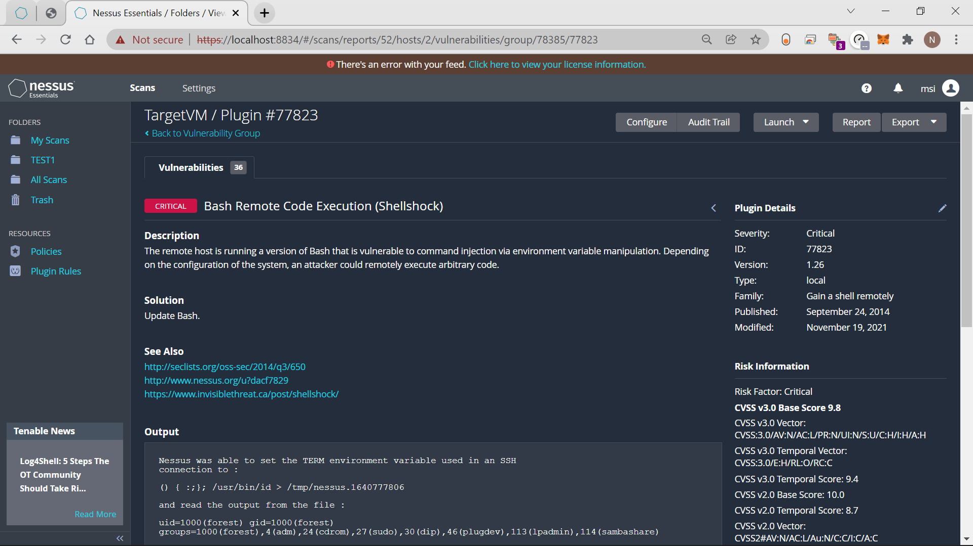 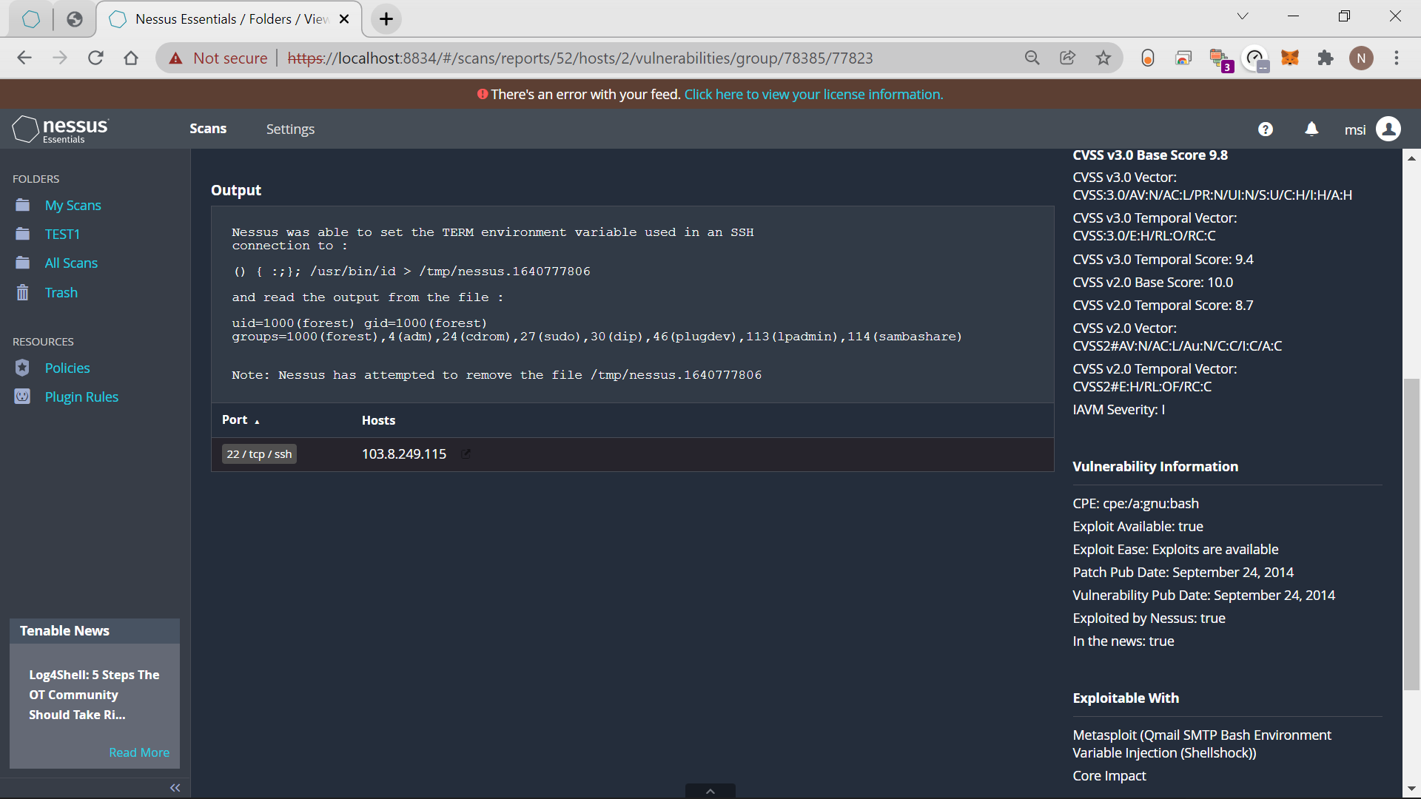



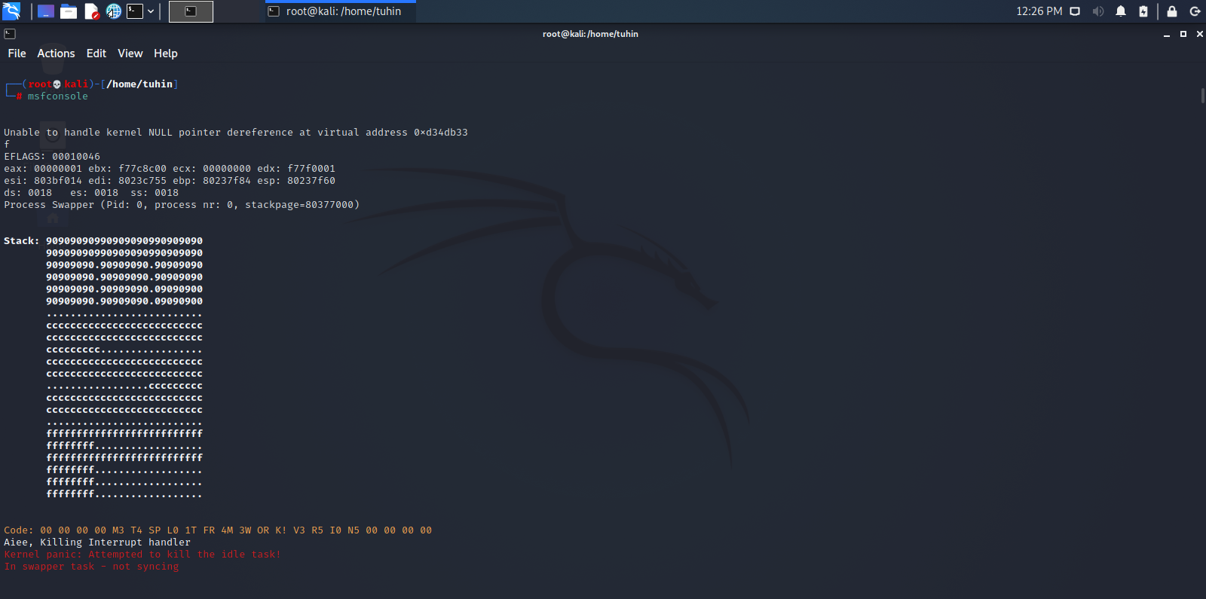

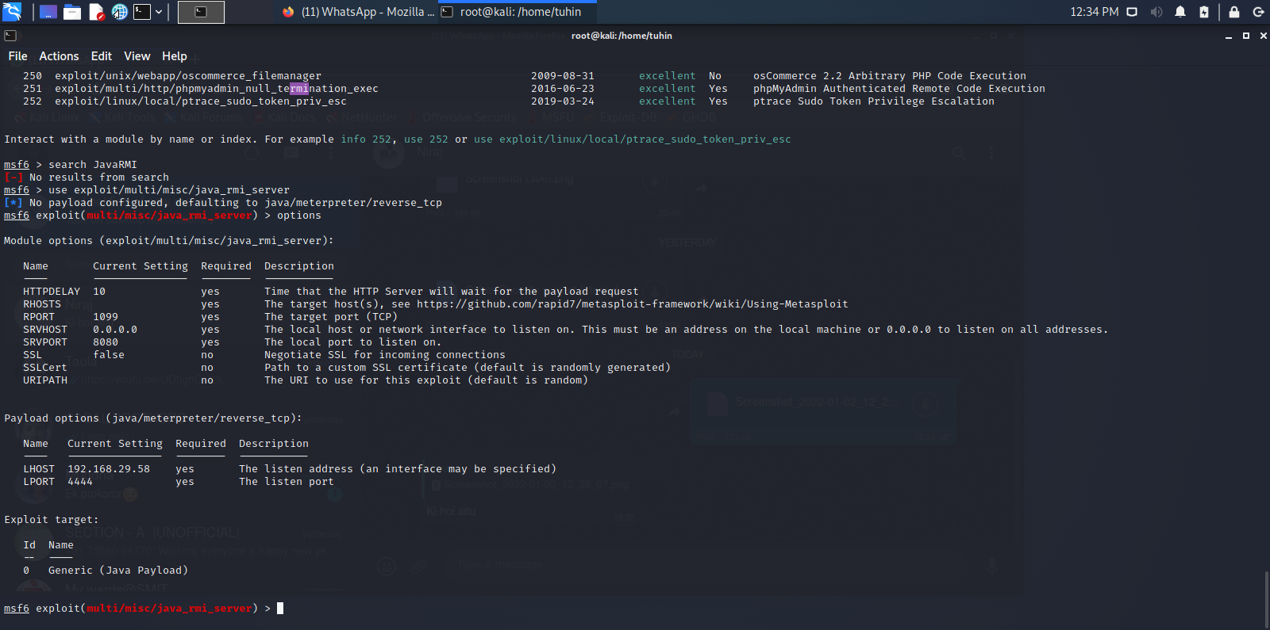

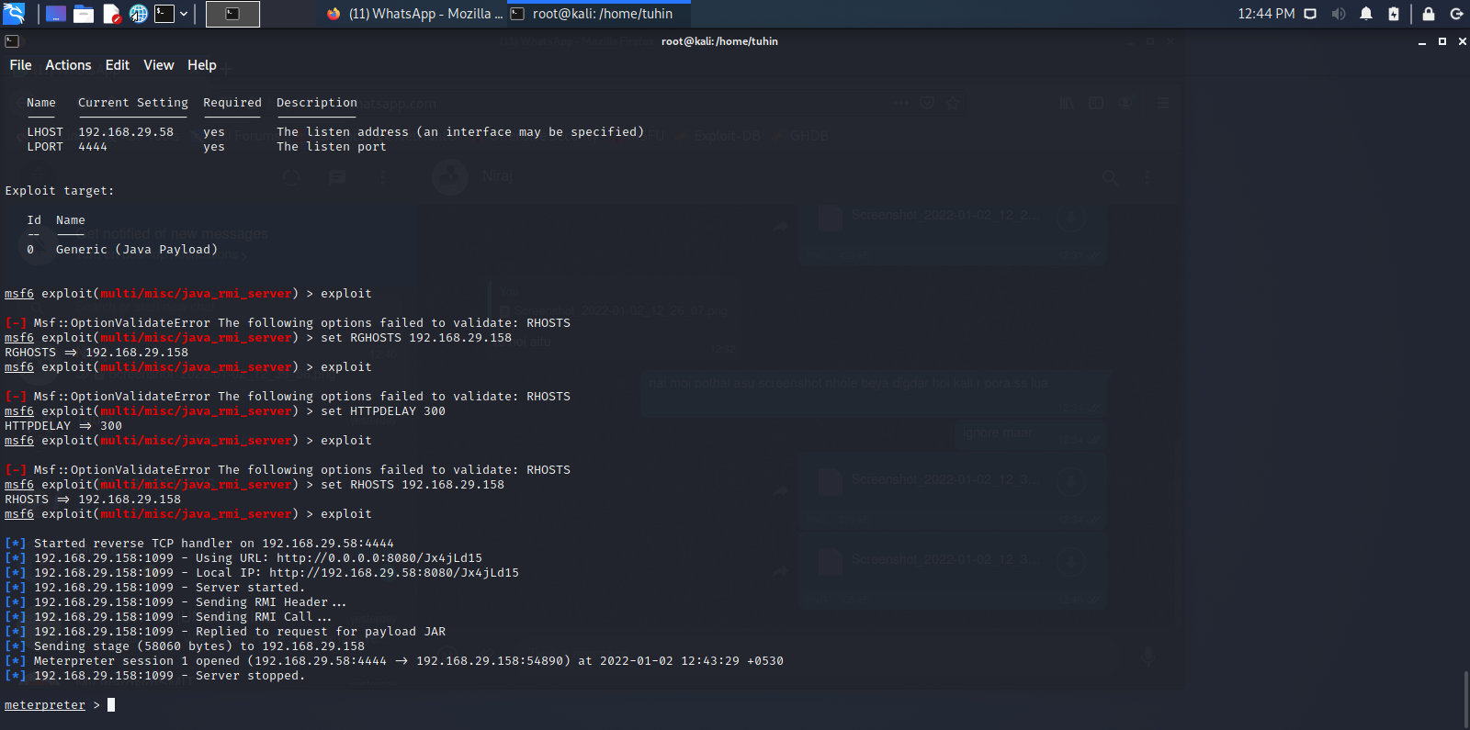

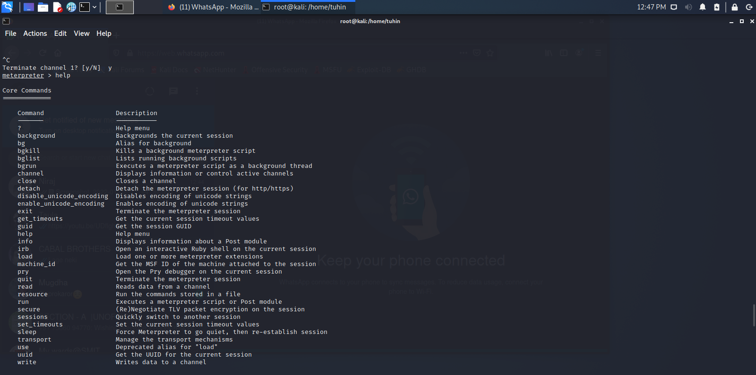

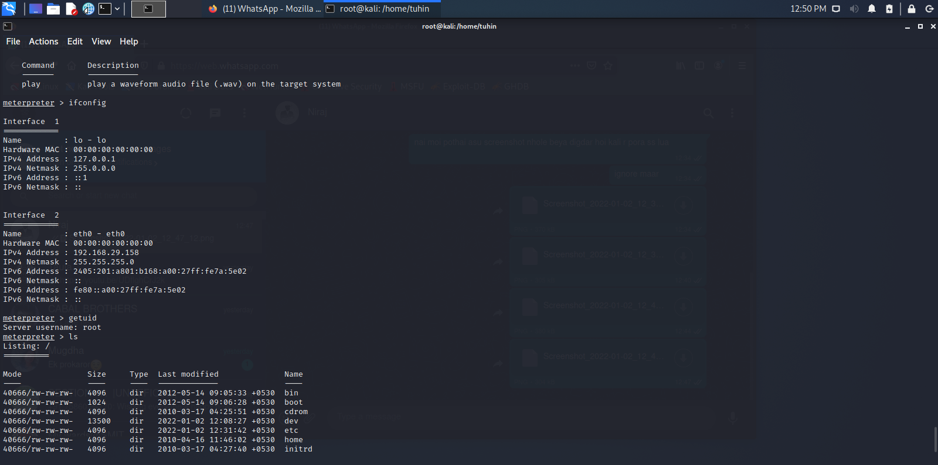

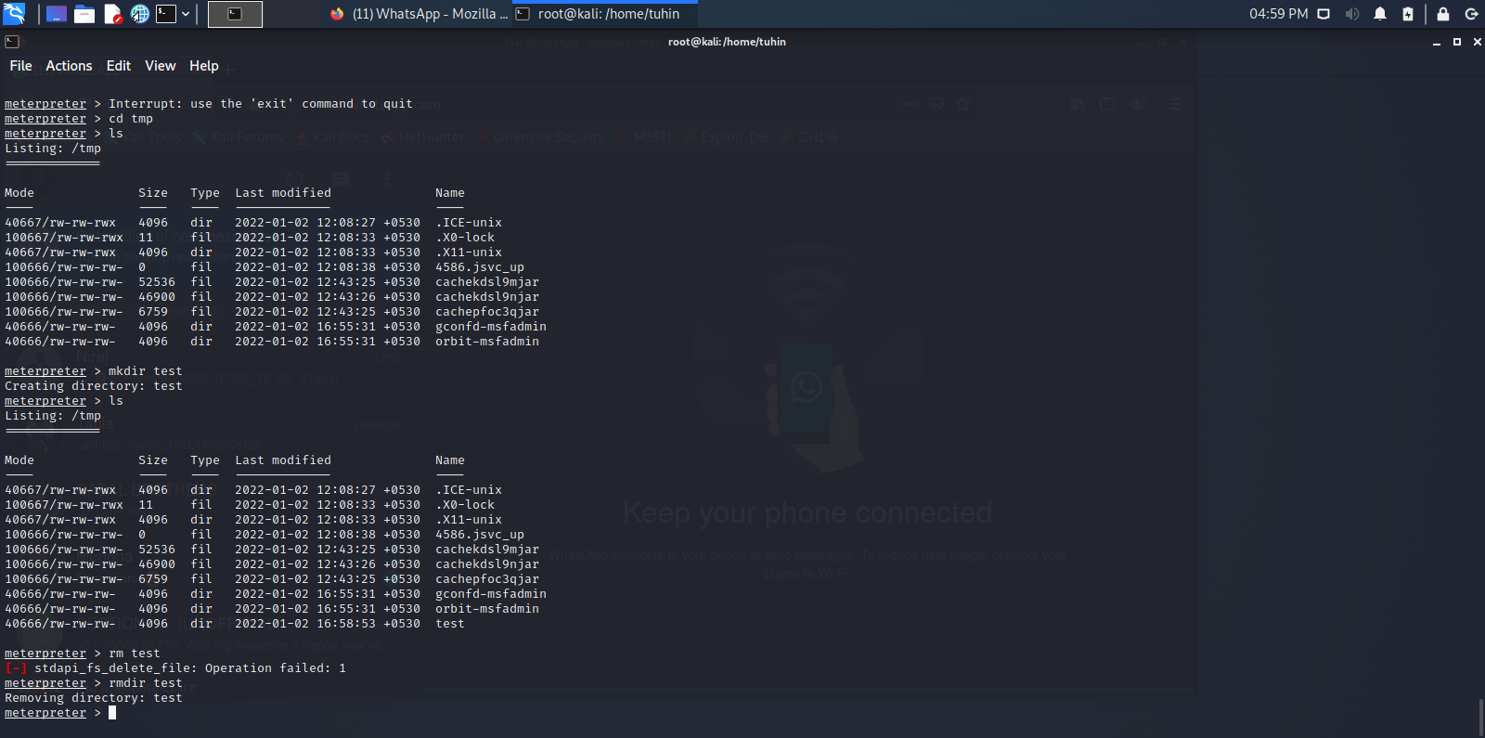

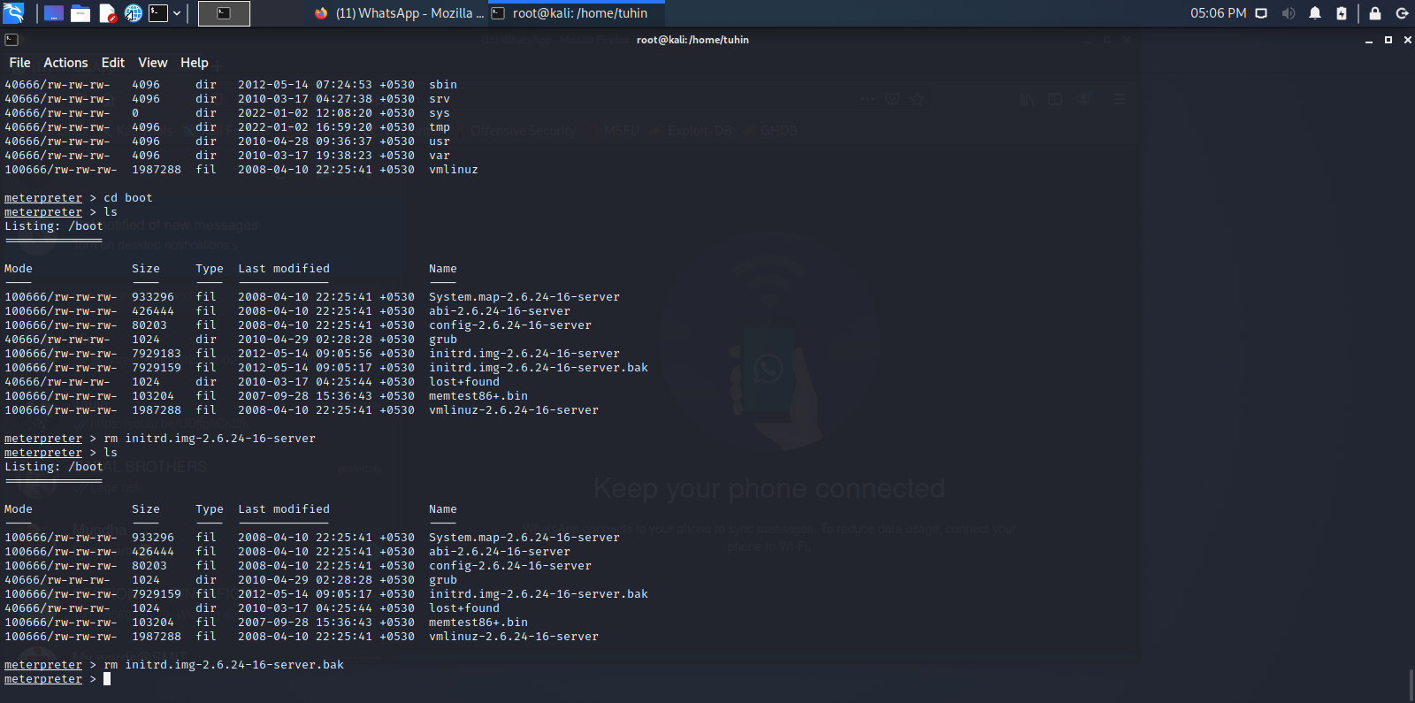

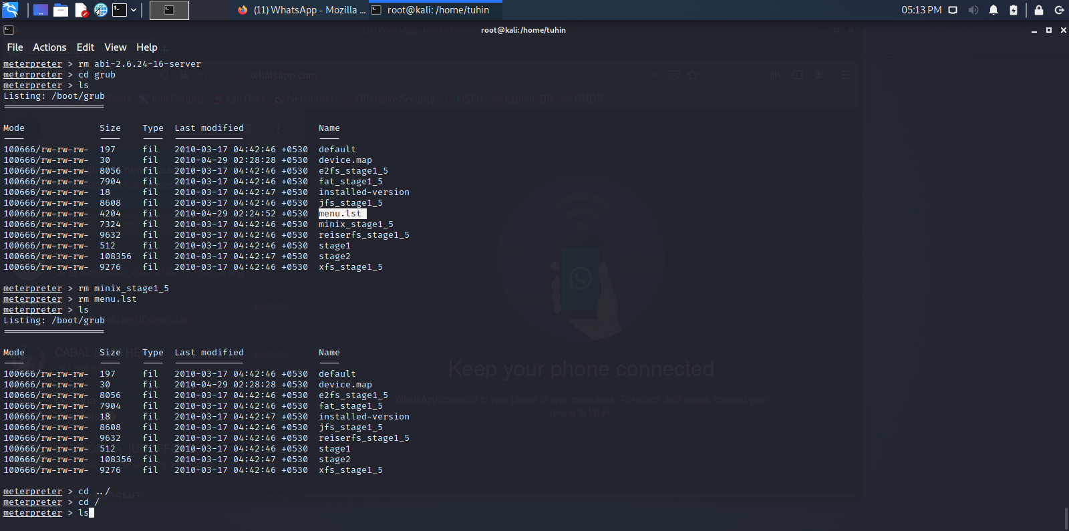

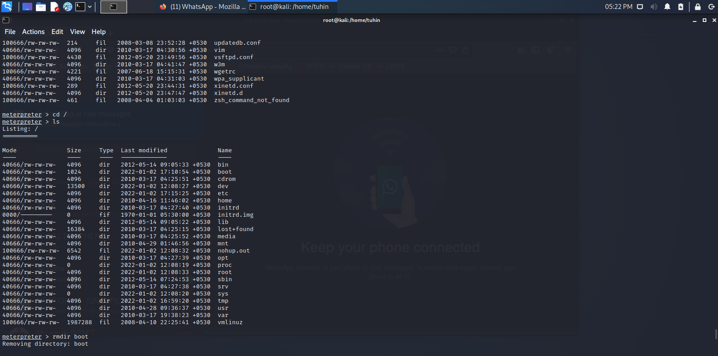

Metasploit after reboot:

